# *Admission Assistant*

UNDERGRADUATE PROJECT

Submitted in partial fulfillment of the requirements of software

***Development project 1 for the degree of***

***B.Sc Engg. in CSE By***

***GROUP: CodE_WaRRiors***

*UNDER SUPERVISION OF:*

*Dipu Akter Shila*

*Teaching Assistant, Dept. of CSE*

*Bangladesh University of Business and Technology*



BANGLADESH UNIVERSITY OF BUSINESS & TECHNOLOGY (BUBT)

Dhaka-1216

March 2021

# *Admission Assistant*

*Group Member list*

*1. Md. Sahenul Islam Chowdhury (19202103022)*

*2. Nahida Zaman Bina (19202103025)*

*3. Md. Sakib Khan (19201103073)*



*BANGLADESH UNIVERSITY OF BUSINESS & TECHNOLOGY (BUBT)*

*DEPARTMENT OF COMPUTER SCIENCE &ENGINEERING*

# *Declaration of Authorship*

We, Md. Sahenul Islam Chowdhury, Nahida Zaman Bina, Md. Sakib khan declare that this project titled,” Admission Assistant ” and the work presented in it are our own.

We, hereby declare that this submission is entirely our own work, in our own words, and that all sources used in researching it are fully acknowledged and all quotations properly identified. We are aware that this offline project of ours published in digital form can be used by everyone without using internet.

It has not been submitted in whole by us for the purpose of obtaining any other credit or grade. We understand the ethical implications of our research and this work meets the requirements of the Faculty of Computer Science Engineering.

***NAME: MD. SAHENUL ISLAM CHOWDHURY***

***ID: 19202103022***

***NAME: NAHIDA ZAMAN BINA***

***ID: 19202103025***

***NAME: MD. SAKIB KHAN***

***Id: 19201103073***

i

# *Certificate*

This is to certify that the project entitled,” Admission Assistant” and submitted by Md. Sahenul Islam Chowdhury, Nahida Zaman Bina, Md. Sakib Khan ID No. 19202103022 ,19202103025, 19201103073 in partial fulfillment of the requirements of embodies the work done by them under my supervision.

*Dipu Akter Shila*

*Teaching Assistant, Department of CSE*

*Bangladesh University of Business and Technology*

ii

# *Dedication*

Dedicated to our parents for all their love and inspiration.

iii

# *Abstract*

Admission Assistant deals with all kinds of university details, academic related details, other resource related details. Admission Assistant tracks all the details of a student for registration. It’s also helps to know about any university information which allows any student to know where the university is located, about the course of the university, available seats in the university and most importantly students can know about the semester fee in any university too.

iv

# *Acknowledgments*

First of all, we are thankful and expressing our gratefulness to Almighty Allah who offers us His divine blessing, patient, mental and physical strength to complete this project work. We are deeply indebted to our project supervisor Dipu Akter Shila, Assistant Teacher, Department of Computer Science and Engineering (CSE), Bangladesh University of Business and Technology (BUBT). His scholarly guidance, important suggestions, work for going through our drafts and correcting them, and generating courage from the beginning to the end of the research work has made the completion of this thesis possible. A very special gratitude goes out to all our friends for their support and help to implement our works. The discussions with them on various topics of our works have been very helpful for us to enrich our knowledge and conception regarding the work. Last but not the least; we are highly grateful to our parents and family members for supporting us spiritually throughout writing this thesis and our life in general.

v

# *Approval*

This project “Admission Assistant” Submitted by Md. Sahenul Islam Chowdhury, Nahida Zaman Bina, Md. Sakib Khan ID No. 19202103022 ,19202103025, 19201103073 Department of Computer Science and Engineering (CSE), Bangladesh University of Business and Technology (BUBT) under the supervision of Dipu Akter Shila; Assistant teacher , Department of Computer Science and Engineering has been accepted as satisfactory for the partial fulfillment of the requirement for the degree of Bachelor of Science (B.Sc. Engg.) in Computer Science and Engineering and approved as to its style and contents.

*Supervisor:*

*Dipu Akter Shila*

*Teaching Assistant*

*Department of CSE.*

*Bangladesh University of Business and Technology (BUBT)*

*Chairman:*

*Dr. Muhammad Firoz Mrida*

*Associate Professor & Chairman*

*Bangladesh University of Business and Technology (BUBT)*

vi

Contents

Declaration of Authorship . . . . . . . . . . . . . . . . . . . . . . . . . . . . . . . . . . . . . i

Certificate . . . . . . . . . . . . . . . . . . . . . . . . . . . . . . . . . . . . . . . . . . . . . . . . . . ii

Abstract . . . . . . . . . . . . . . . . . . . . . . . . . . . . . . . . . . . . . . . . . . . . . . . . . . . . iv

Acknowledgments . . . . . . . . . . . . . . . . . . . . . . . . . . . . . . . . . . . . . . . . . . v

Approval . . . . . . . . . . . . . . . . . . . . . . . . . . . . . . . . . . . . . . . . . . . . . . . . . . . vi

Contents . . . . . . . . . . . . . . . . . . . . . . . . . . . . . . . . . . . . . . . . . . . . . . . . . . . vii

1 Introduction 1

1.1 Introduction . . . . . . . . . . . . . . . . . . . . . . . . . . . . . . . . . . . . . . . . . 1

2 Technologies 2

2.1 Software . . . . . . . . . . . . . . . . . . . . . . . . . . . . . . . . . . . . . 2

2.1.1 Code::Blocks . . . . . . . . . . . . . . . . . . . . . . . . . . . . . . . . . 2

2.2 Programming Language . . . . . . . . . . . . . . . . . . . . . . . . . . 3

2.2.1 C Language . . . . . . . . . . . . . . . . . . . . . . . . . . . . . . . . . . 3

3 System Analysis & Architectural Design 5

3.1 Flowchart . . . . . . . . . . . . . . . . . . . . . . . . . . . . . . . . . . . . . 5

3.2 System User Analysis . . . . . . . . . . . . . . . . . . . . . . . . . . . 5

3.2.1 ADMINISTRATOR: . . . . . . . . . . . . . . . . . . . . . . . . . . . . 6

3.2.2 STUDENT: . . . . . . . . . . . . . . . . . . . . . . . . . . . . . . . . . . . 7

3.2.3 AUTHORITY: . . . . . . . . . . . . . . . . . . . . . . . . . . . . . . . . . 7

3.3 Architectural Design . . . . . . . . . . . . . . . . . . . . . . . . . . . . 7

4 Access System 9

4.1 Description . . . . . . . . . . . . . . . . . . . . . . . . . . . . . . . . . . . . 9

4.2 Manual . . . . . . . . . . . . . . . . . . . . . . . . . . . . . . . . . . . . . . . 9

5 Code Analysis 29

5.1 CODE . . . . . . . . . . . . . . . . . . . . . . . . . . . . . . . . . . . . . . . . . 29

6 Future plan 61

6.1 Future plan . . . . . . . . . . . . . . . . . . . . . . . . . . . . . . . . . . . . . 61

7 Conclusion 62

7.1 Conclusion . . . . . . . . . . . . . . . . . . . . . . . . . . . . . . . . . . . . . . 62

Vii

Chapter 1.Introduction 1

Chapter 1

Introduction

1.1 Introduction

Admission Assistant deals with all kinds of university details, academic related details, Other resource related details. It tracks all the details of a student which is important to registration purpose for any university which can be used for student’s personal information, Admit card, Registered University etc. Our project can help in highlighting the current status of universities in our country to all students. The Admission Assistant project can provide all the information about all universities, faculty name, Number of seats, full course fee and also waiver system too. With the help of our project anyone can do their work in a short time. If something goes wrong, our project will give an alarm through which the wrong work can be corrected. Everyone has to login to enter this project. If someone is already logged in, they can login with their name and password. After logging in, he/she can go to university information and find out about the University of their Choice. Later, he/she can register at the University of his/her choice. If a student has already registered, he/she can go to my information and see his/her details. Our project has six modules, they are university information, registration, my information, circular and exam date, university rank list, log out. These modules and its attributes with entity relationship module presented in figure section.

Chapter 2. Technologies 2

Chapter 2

Technologies

2.1 Software

2.1.1 Code::Blocks

Code::Blocks is a free, open-source cross-platform IDE that supports multiple compilers including GCC, Clang and Visual C++. It is developed in C++ using wxWidgets as the GUI toolkit. Using a plugin architecture, its capabilities and features are defined by the provided plugins. Currently, Code::Blocks is oriented towards C, C++, and Fortran. It has a custom build system and optional Make support. Code::Blocks is being developed for Windows and Linux (the latest macOS version is 13.12

released on 12/26/2013) and has been ported to FreeBSD, OpenBSD and Solaris.

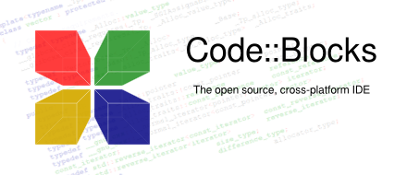

Figure 2.1: CodeB::locks

After releasing two release candidate versions, 1.0rc1 on July 25, 2005 and 1.0rc2 on October 25, 2005, instead of making a final release, the project developers started adding many new features, with the final release being repeatedly postponed. Instead, there were nightly builds of the latest SVN version made available on a daily basis.[citation needed] The first stable release was on February 28, 2008, with the version number changed to 8.02. The versioning scheme was changed to that of

Chapter 2. Technologies 3

Ubuntu, with the major and minor number representing the year and month of the release. Version 17.12 is the latest stable release; however for the most up-to-date version the user can download the relatively stable nightly build or download the source code from SVN. Jennic Limited distributes a version of Code::Blocks customized to work with its microcontrollers.[Wikipedia]

2.2 Programming Language

2.2.1 C Language

C (/si/, as in the letter c) is a general-purpose, imperative computer programming language, supporting structured programming, lexical variable scope and recursion, while a static type system prevents many unintended operations. By design, C provides constructs that map efficiently to typical machine instructions, and therefore it has found lasting use in applica- tions that had formerly been coded in assembly language, including operating systems, as well as various application software for computers ranging from supercomputers to embedded systems.



Figure 2.2: C Language

Chapter 2. Technologies 4

Many later languages have borrowed directly or indirectly from C, including C, C#, Unix’s C shell, D, Go, Java, JavaScript, Limbo, LPC, Objective-C, Perl, PHP, Python, Rust, Swift, Verilog and System Verilog (hardware description languages). These languages have drawn many of their control structures and other basic features from C. Most of them (with Python being the most dramatic exception) are also very syntactically similar to C in general, and they tend to combine the recognizable expression and statement syntax of C with underlying type systems, data models, and semantics that can be radically different.[Wikipedia]

Chapter 3. System Analysis & Architectural Design 5

Chapter 3

System Analysis & Architectural Design

3.1 Flowchart:

Exit

Logout

Show all universities rank list

Show select universities admit card

Show universities name

Show all universities circular & exam date

Show all universities

Circular & exam date

University

Rank List

Show Registered universities name

Admit Card

Registered university

My information

successfully registered

Payment

Form fill-up

All university name

Private Universities

name

Private

Public Universities name

Public

Registration

University

Information

Admission

Assistant

Login

Chapter 3. System Analysis & Architectural Design 6

* 1. System User Analysis:

The Admission Assistant has three types of user and they can access the system.

USER:

• Administrator.

• Student.

University Information

• Authority.

Authority

Registration

My Information

Student

**Admin**

Circular and Exam date

University Rank list

Log out

Figure 3.2: User Analysis

3.2.1 ADMINISTRATOR:

Like another system in this system administrator also can access all modules. They can create record, search record, delete record, view all student record and update or modify record. But create, update and delete options access is only under them. Any second party couldn’t get access this options.

Chapter 3. System Analysis & Architectural Design 7

3.2.2 STUDENT:

In this system student can access all options. That is UNIVERSITY INFORMATION, REGISTRATION, MY INFORMATION, CIRCULAR AND EXAM DATE, UNIVERSITY RANK LIST, LOGOUT option student can get specific student record. But there exist one condition. There must have to be stored record for the registered student. Using MY INFORMATION option student can get all students record. This record is not restricted.

3.2.3 AUTHORITY:

Like another system in this system Authority also can access Registration module. The university authorities will have a connection with our project. The information that when a student has registered and at which university will go to the authorities.

3.3 Architectural Design:

The Admission Assistant is system which has major components such as UNIVERSITY INFORMATION, REGISTRATION, MY INFORMATION, CIRCULAR AND EXAM DATE, UNIVERSITY RANK LIST, LOGOUT, Perform specific statement for specific user. Admin can create University information, add university’s details, Add changes in any information. Then students can searching their admit card, exam date, university location, they can also modify their registration form. The system acts and the rest of the functions are performed respectively based on the input by the user. The administrator has automatic access right to manage and maintain university’s detail. The student can only view their details. And authority can also get information about student’s registration.

After run this system it will display the page like Figure: 3.2. And the homepage design is like,

Loading:

We put a loading process at the beginning of our project. The project cannot be entered and used until the loading is complete.

Chapter 3. System Analysis & Architectural Design 8

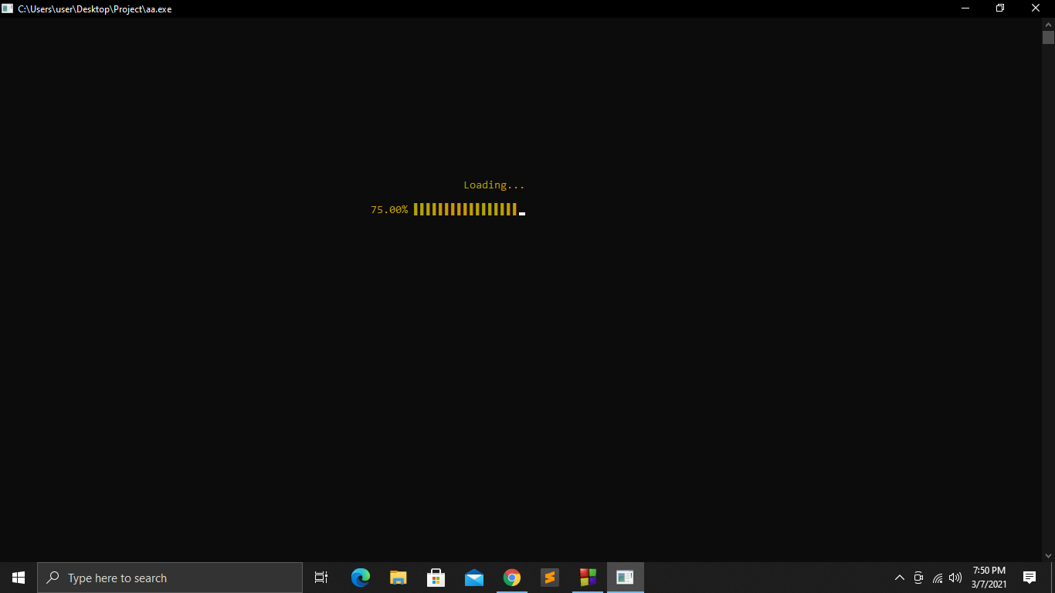

Figure:3.2

After 100% loading, this will show a successful message like Figure: 3.3 through which you will able to use the project.

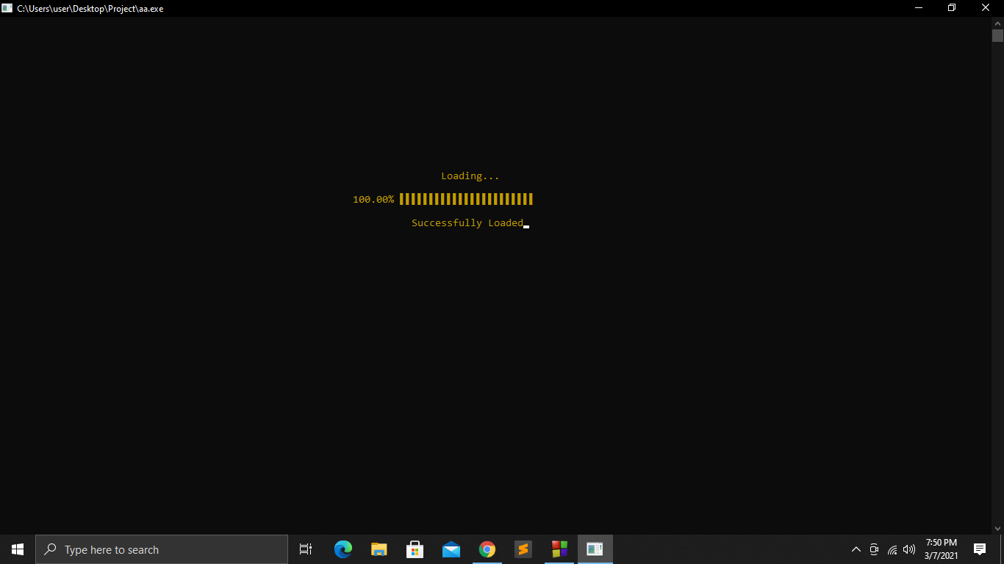

Figure:3.3

You will get the complete design of this system in next chapter (Access System).

Chapter 4. Access System 9

Chapter 4

Access System

4.1 Description:

By reading this chapter user can know about every options of this system as like, how to operate this system, who can operate this system and all restrictions.

4.2 Manual:

At first run the system. You can see a loading page like figure: (3.2).This is not the home page. After the loading page there will come a page that will show if I had an account before like figure: (4.1).

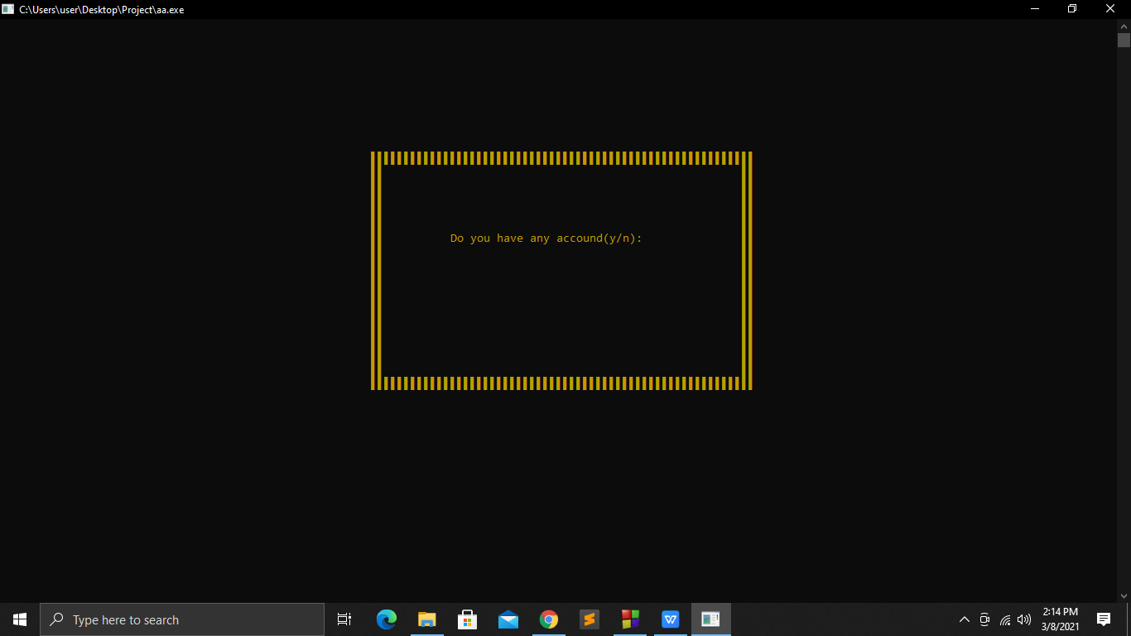

Figure: 4.1

1. If I had an account before then I can login with my registered name and password like figure:(4.2).

Chapter 4. Access System 10

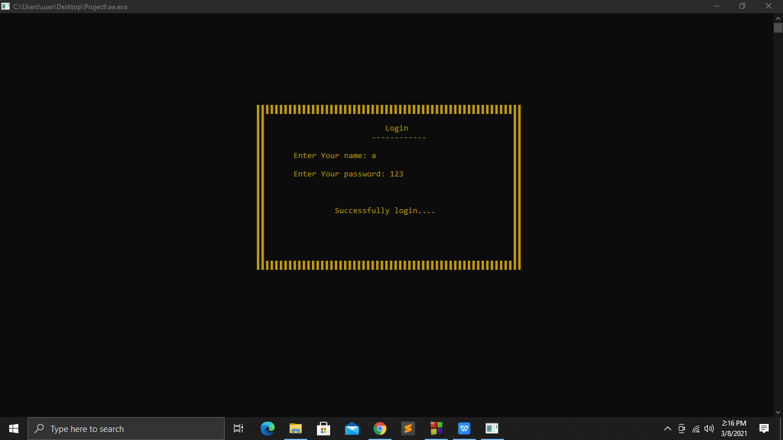

Figure: 4.2

1. If the password is wrong 3 times the project will show a alarming message, then students have to re-open the account and enter the project like figure :(4.3).

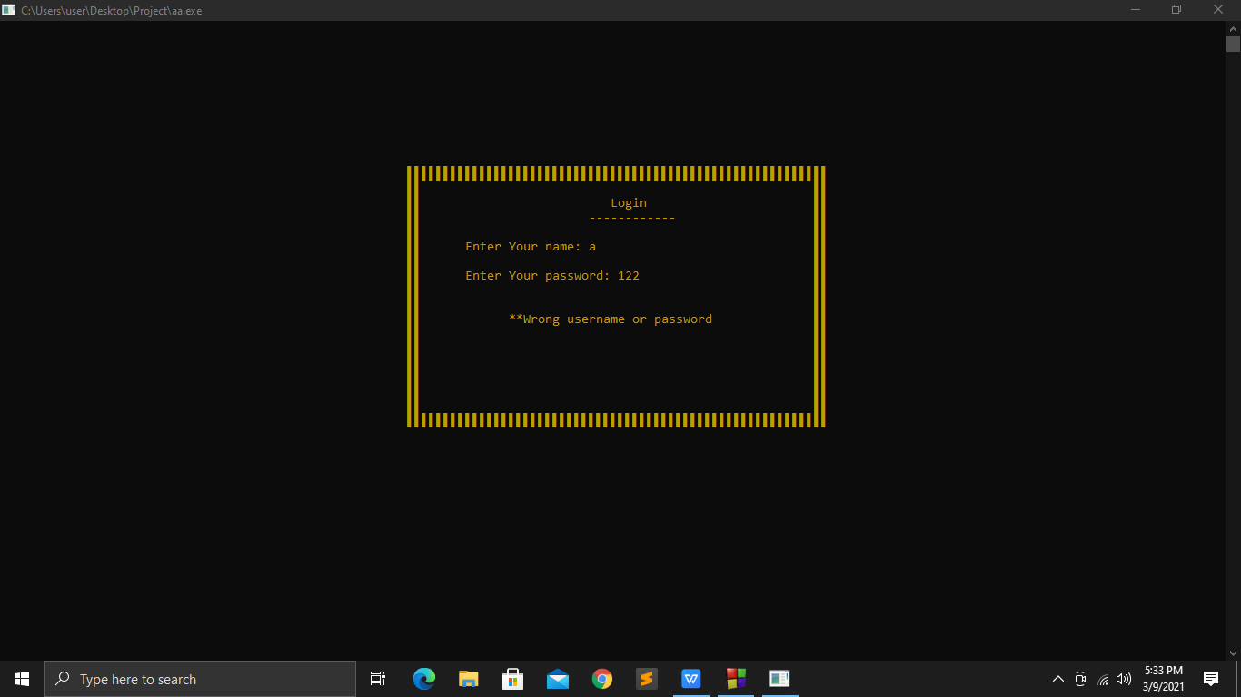 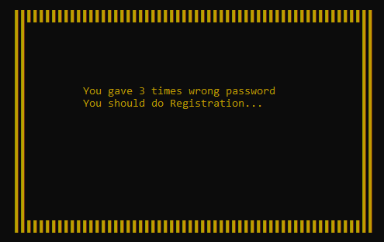

Figure:4.3

4.If I do not have an account before, a registration form will be shown where an account with name,password,phone number and birth date will be registred to access this project at any time like figure:(4.4).

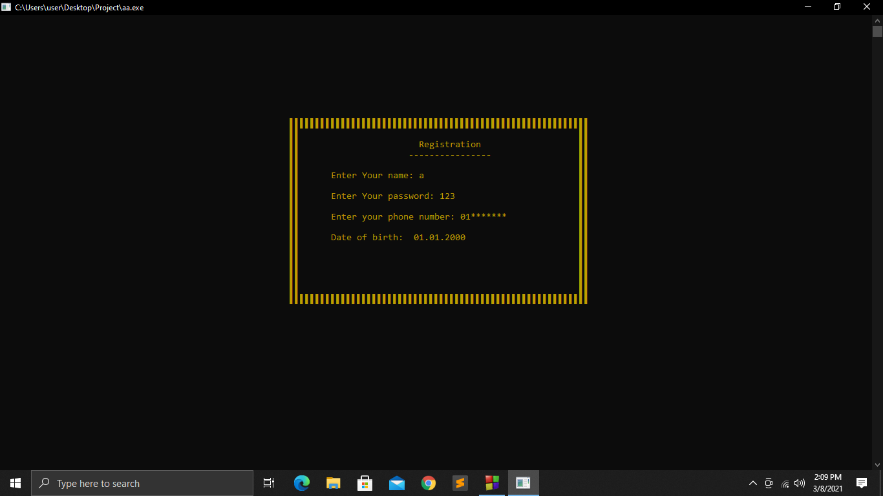

Figure: 4.4

Chapter 4. Access System 11

5.After successfully registration and login process students will be able to enter the home page of our project. Where we have all the modules like figure:(4.5)

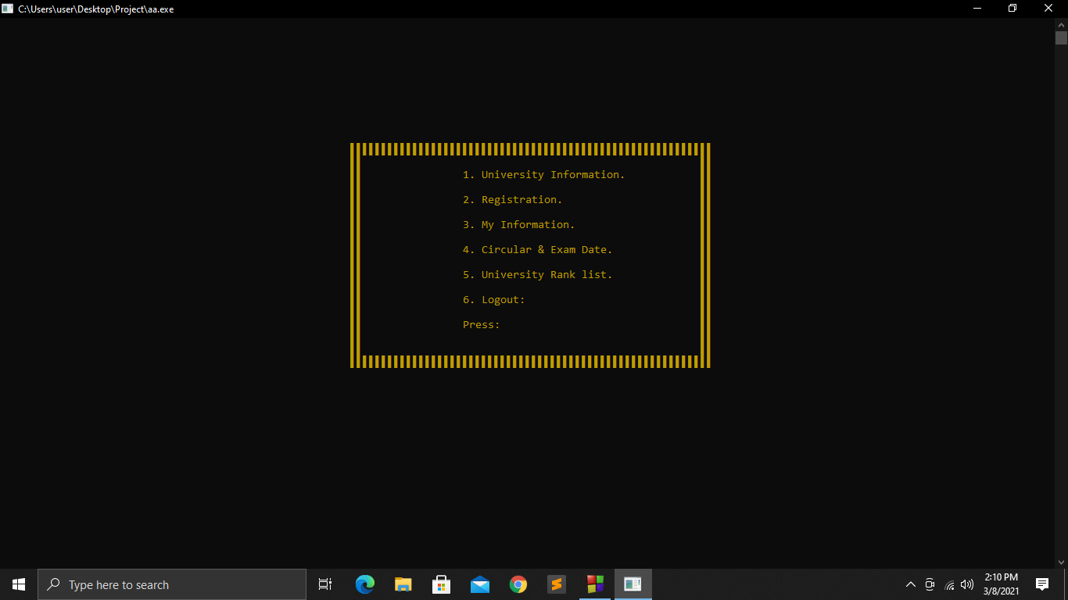

Figure: 4.5

6.If the student gives 1 in the press option, it will go into the university information like figure:(4.6)

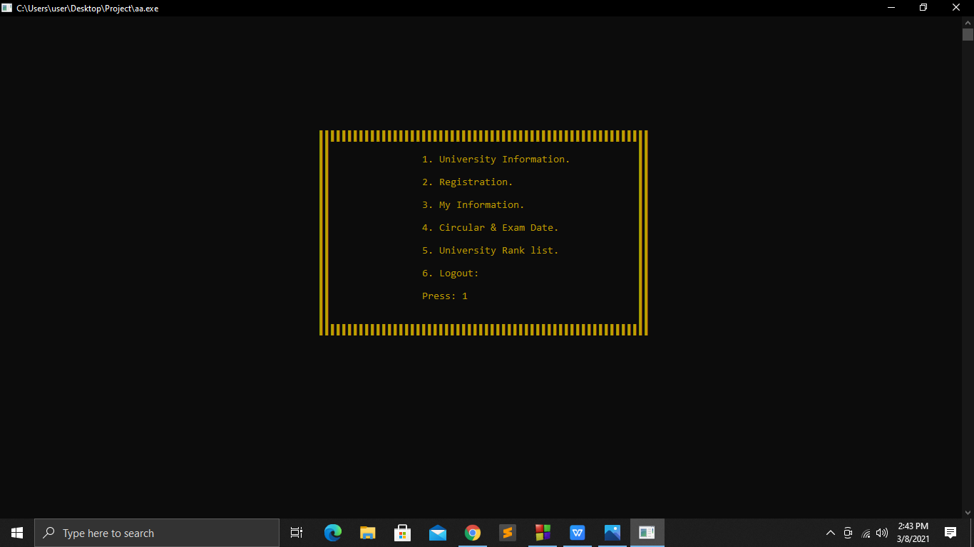

Figure: 4.6

7.There are 3 options in University Information. If any student press 1 , then the public universities will be shown like figure:(4.7)

Chapter 4. Access System 12

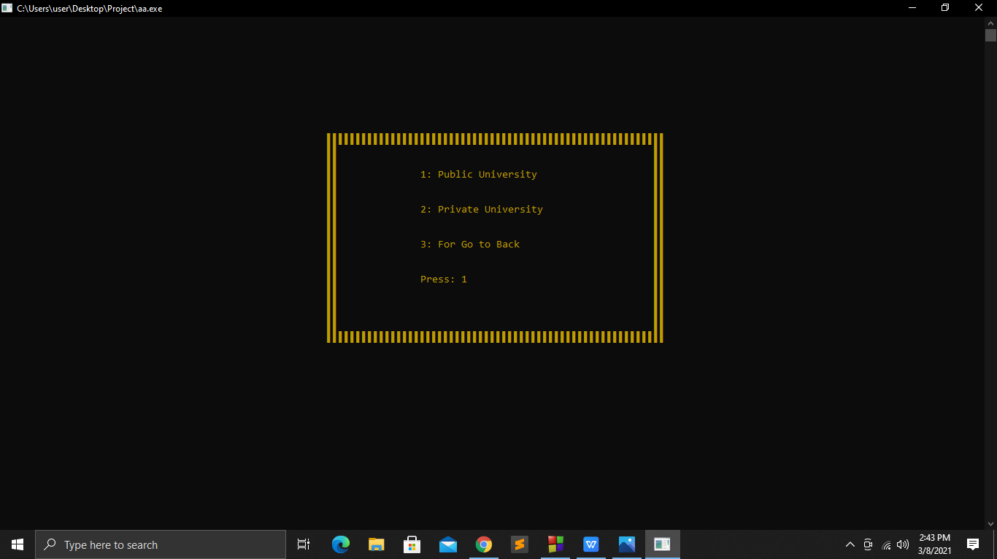

Figure: 4.7

8.If any student make a choice among the public universities, the information of that university will be shown at the same time. Like figure : (4.8) and figure: (4.9)

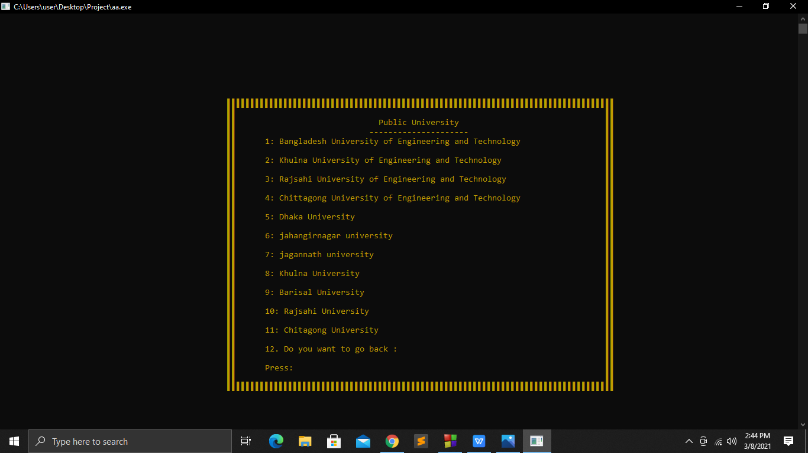

Figure: 4.8

Chapter 4. Access System 13

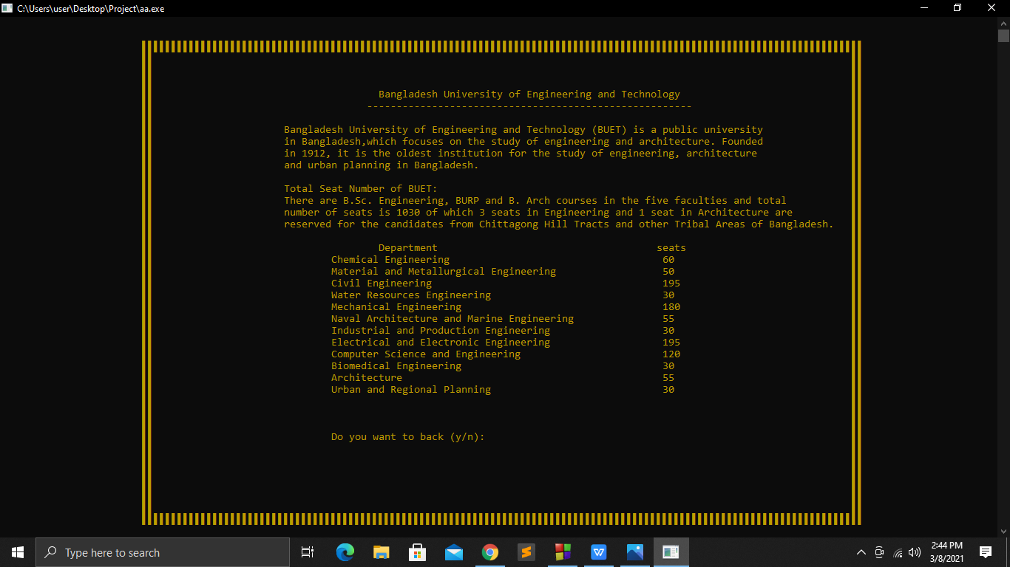

Figure: 4.9

9. Here is an option to go to the previous page. If anyone press ‘y’ then it will go to the prevous page like figure: (4.10)

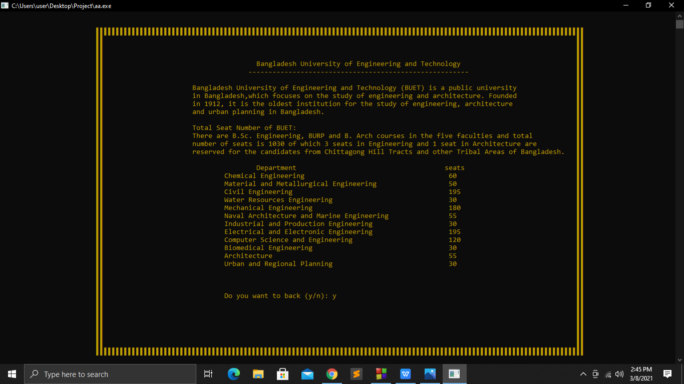

Figure: 4.10

Chapter 4. Access System 14

10. Pressing 12 to go to the next page again will take you to Figure:(4.7) page like figure :(4.8) .

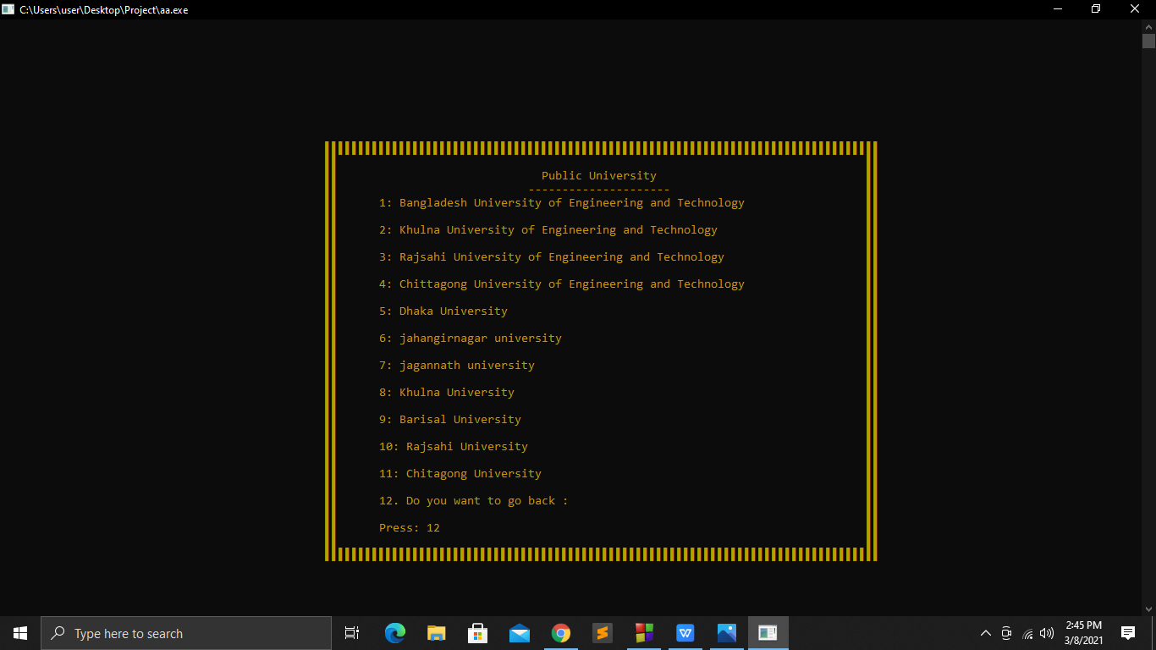

Figure: 4.8

11. If we press 2 again in figure:4.7, then the private universities will shown like figure: (4.12) and figure: (4.13).

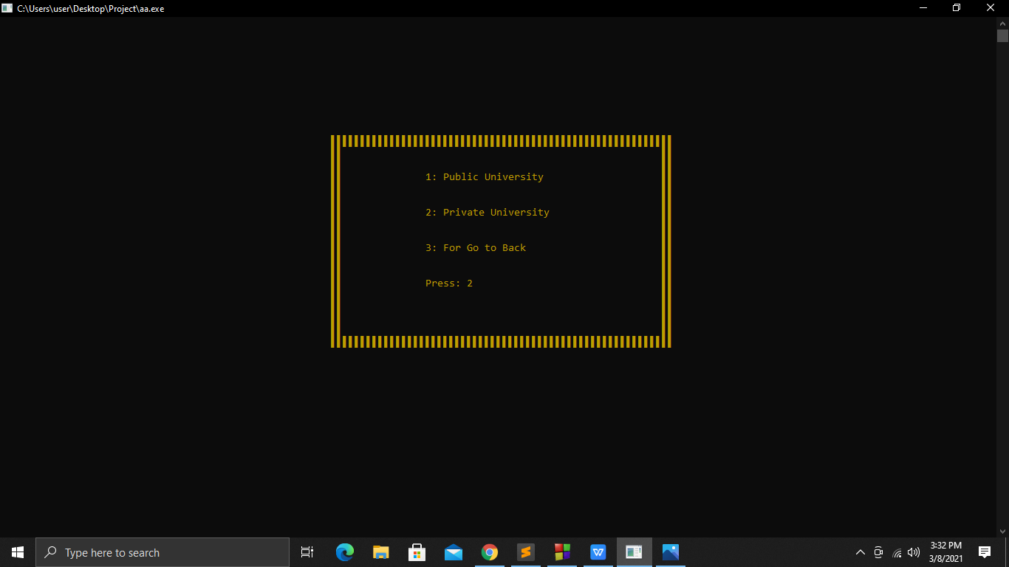

Figure: 4.12

Chapter 4. Access System 15

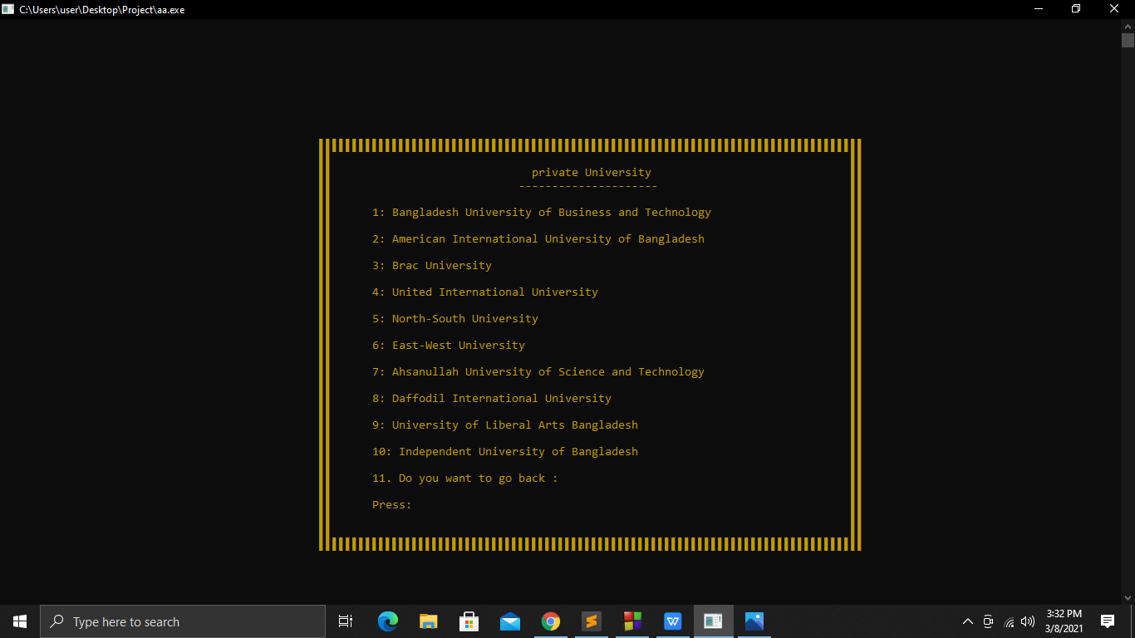

Figure: 4.13

12.If any student make a choice among the private universities, the information of that university will be shown at the same time like figure: (4.14).

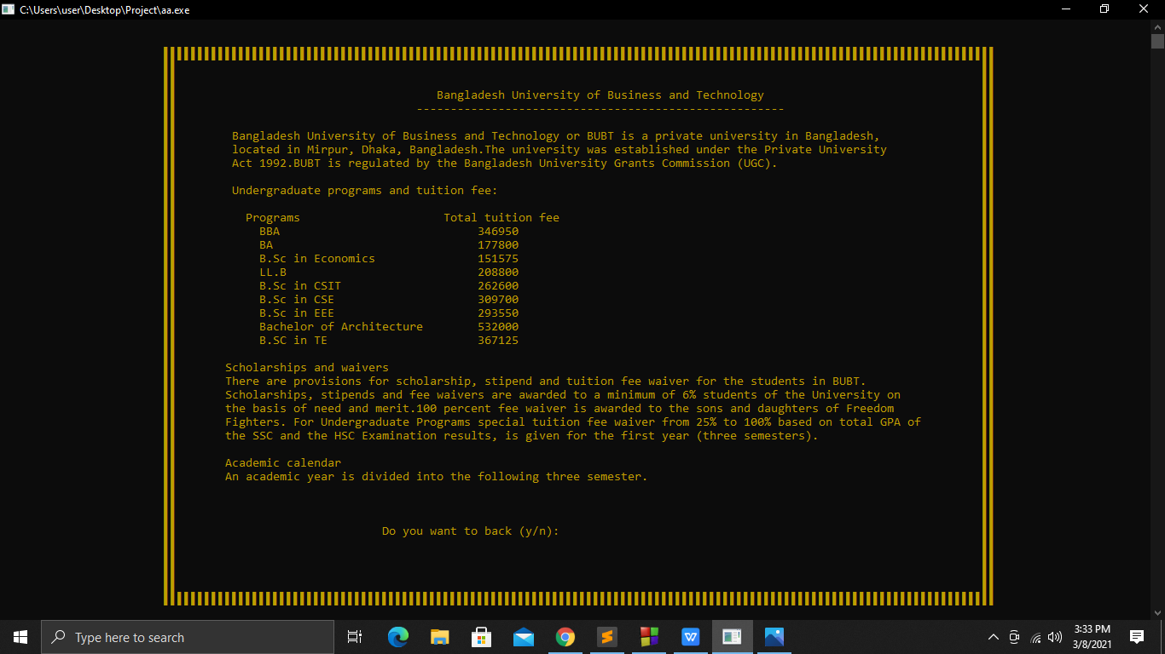

Figure: 4.14

13. Here is an option to go to the previous page. If anyone press ‘y’ then it will go to the previous page like figure: (4.15)

Chapter 4. Access System 16

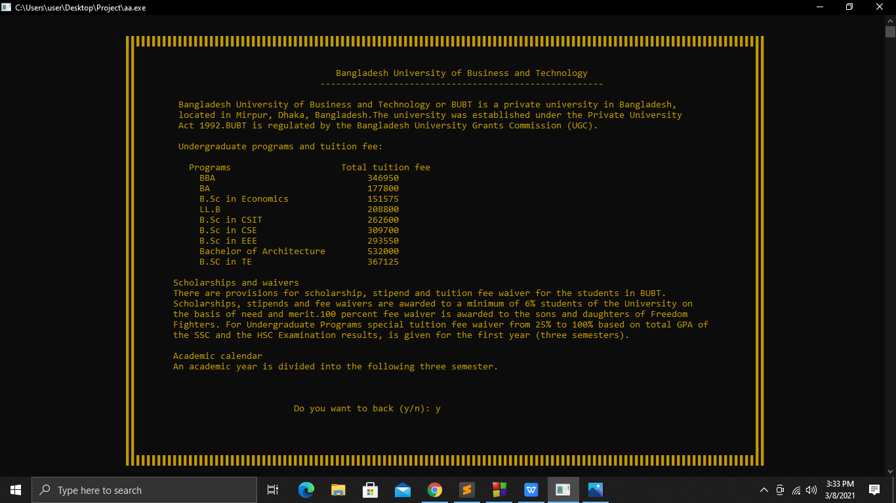

Figure: 4.15

14. Pressing 11 to go to the next page again will take you to Figure:(4.7) page like figure :(19)

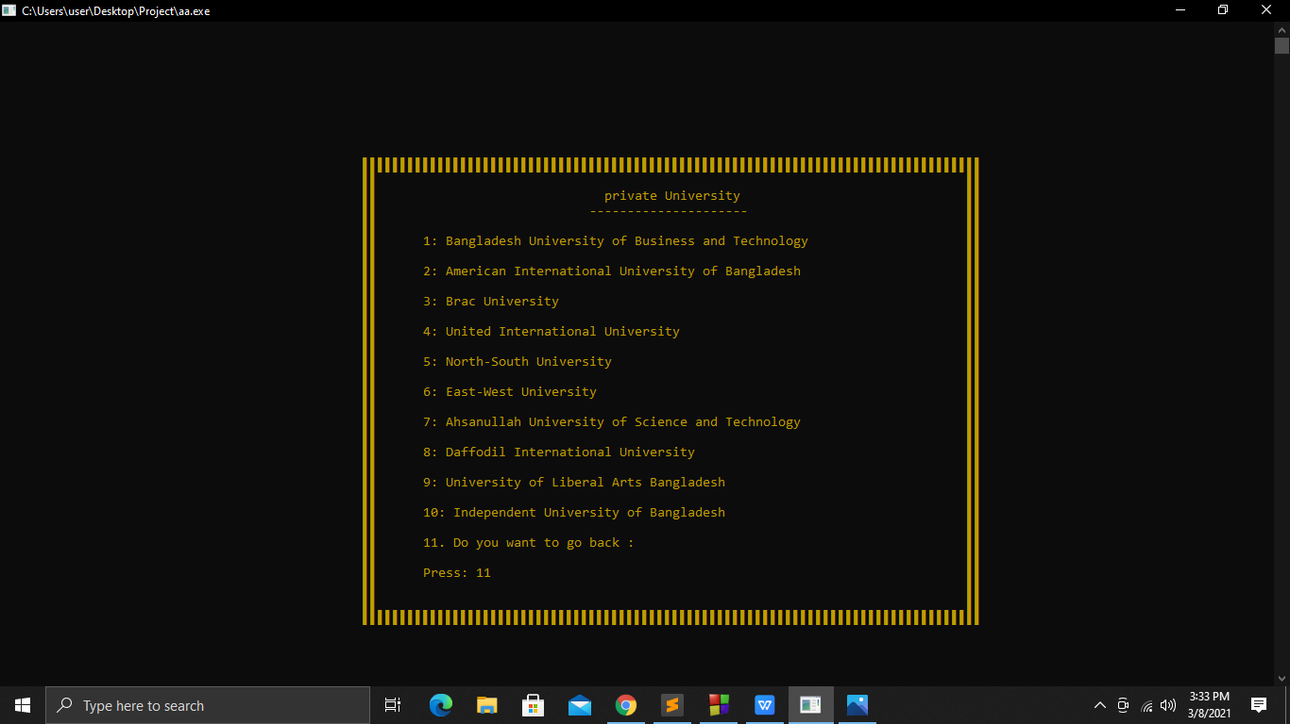

Figure: 4.16

15. If we press 3 again in figure:4.7, then the home page will shown like figure: (4.17).

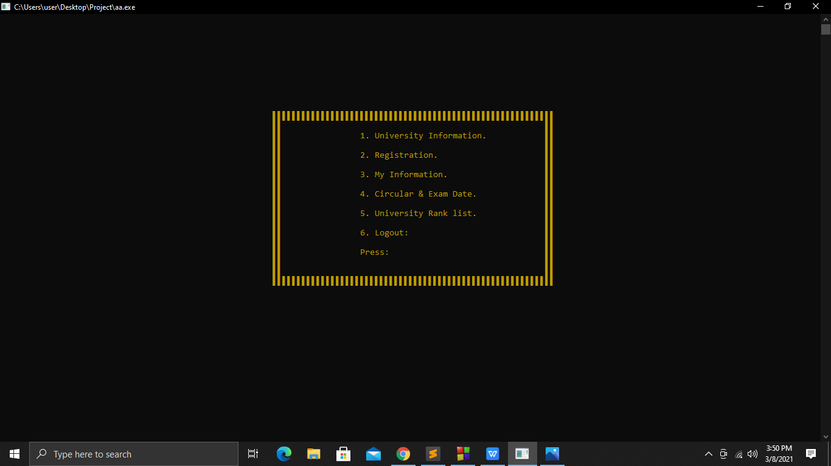

Figure: 4.17

Chapter 4. Access System 17

16. If the student gives 2 in the press option, it will go into the Registration option like figure:(4.18) and figure:(4.19)

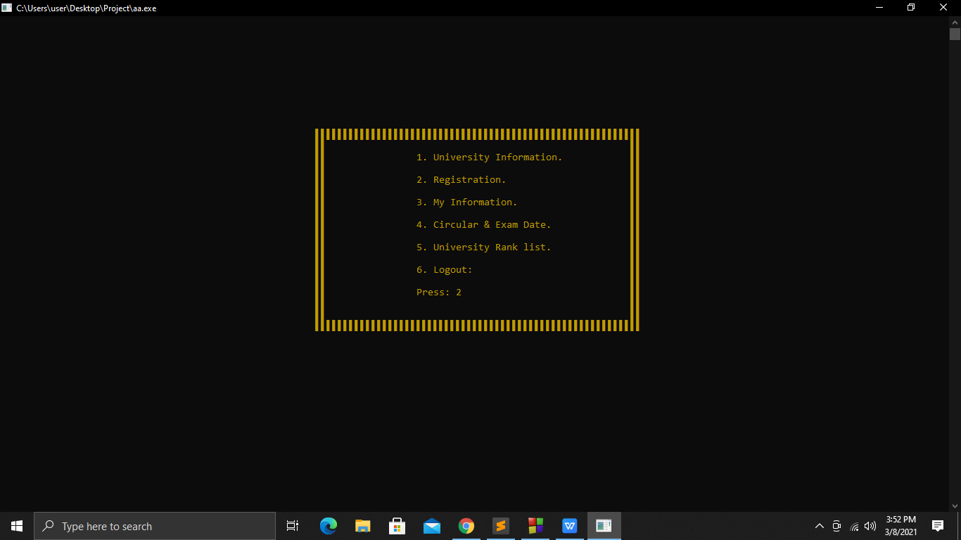

Figure: 4.18

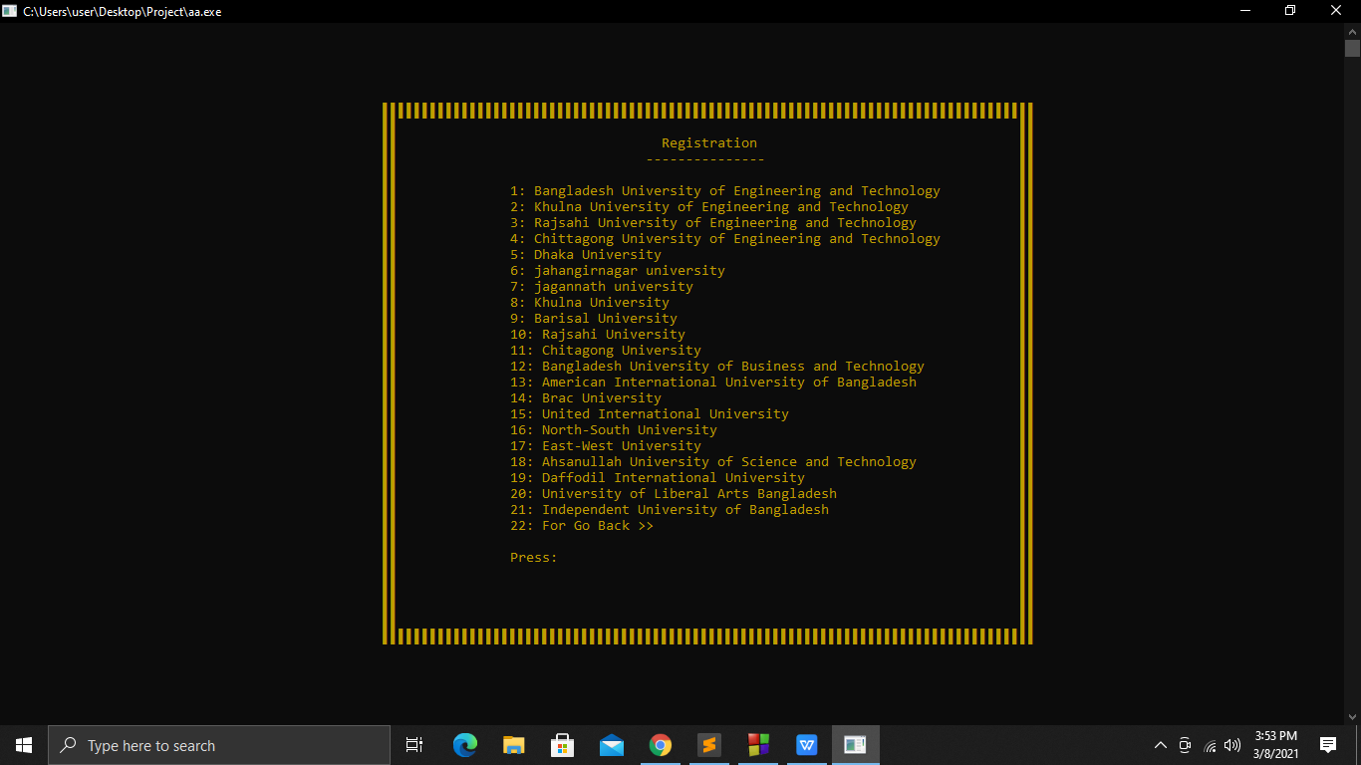

Figure: 4.19

17. If any student enter the serial number of the university in the press option to register in the University of their Choice, they will go to the registration page where they can go to the next page by completing the registration with name, HSC roll, HSC registration number, birth date, HSC passed year like figure: (4.20).

Chapter 4. Access System 18

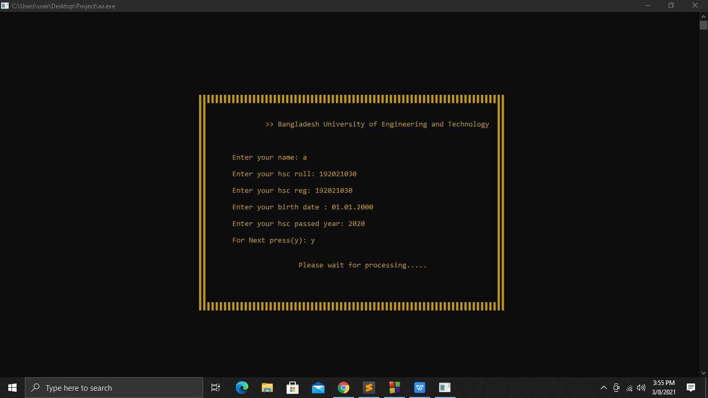

Figure: 4.20

18. Payment is time after the registration process is over. Payment can be complete in 3 ways. If any student press any one of the choices, it will take a while to go to the payment option like figure :(4.21).

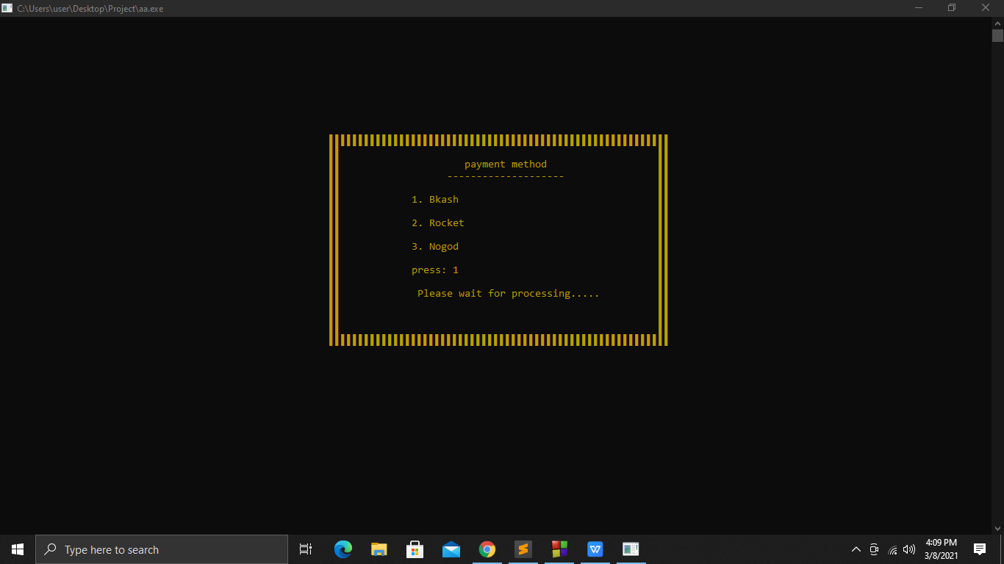

Figure: 4.21

Chapter 4. Access System 19

19.If any student go to the payment option and clear the payment with the sender’s number, code number, and id number the registration will be complete like figure:(4.22). And will go back to figure:(4.5)

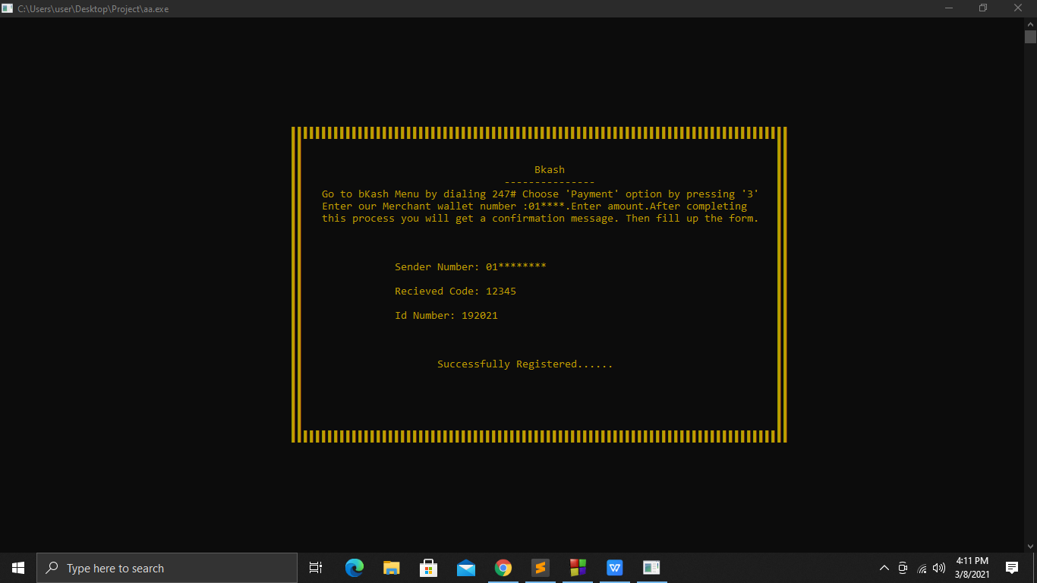

Figure: 4.22

20.After visiting the home page, if a student wants to know about his/her information he/she can know his/her information by pressing 3 like figure:(4.23).

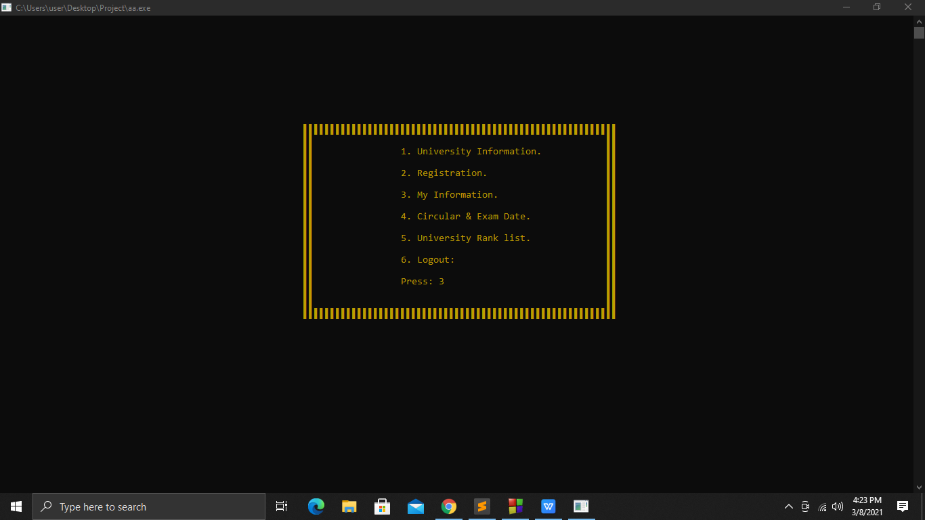

Figure: 4.23

Chapter 4. Access System 20

21. The next page after pressing three will have 3 options. If any student press the 1st option, they will be able to see the universities that they have registered with. Like figure:(4.24) and figure:(4.25).

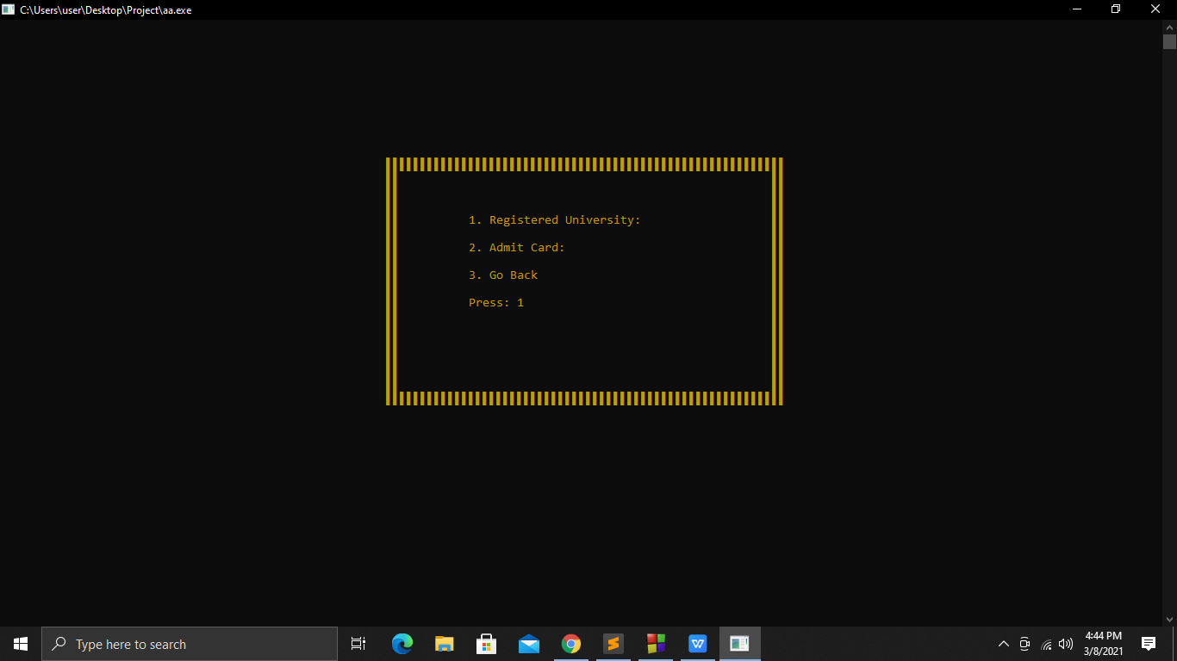

Figure: 4.24

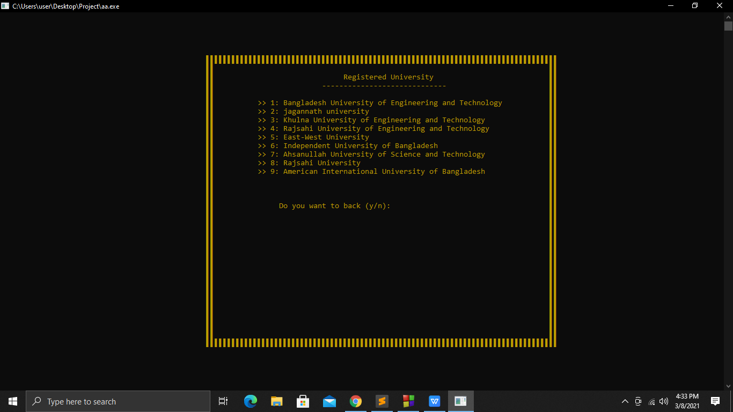

Figure: 4.25

Chapter 4. Access System 21

22.If any student want to go back to the previous page after visiting the registered university , they have to press “y” like figure:(4.26). And will go back to figure:4.24

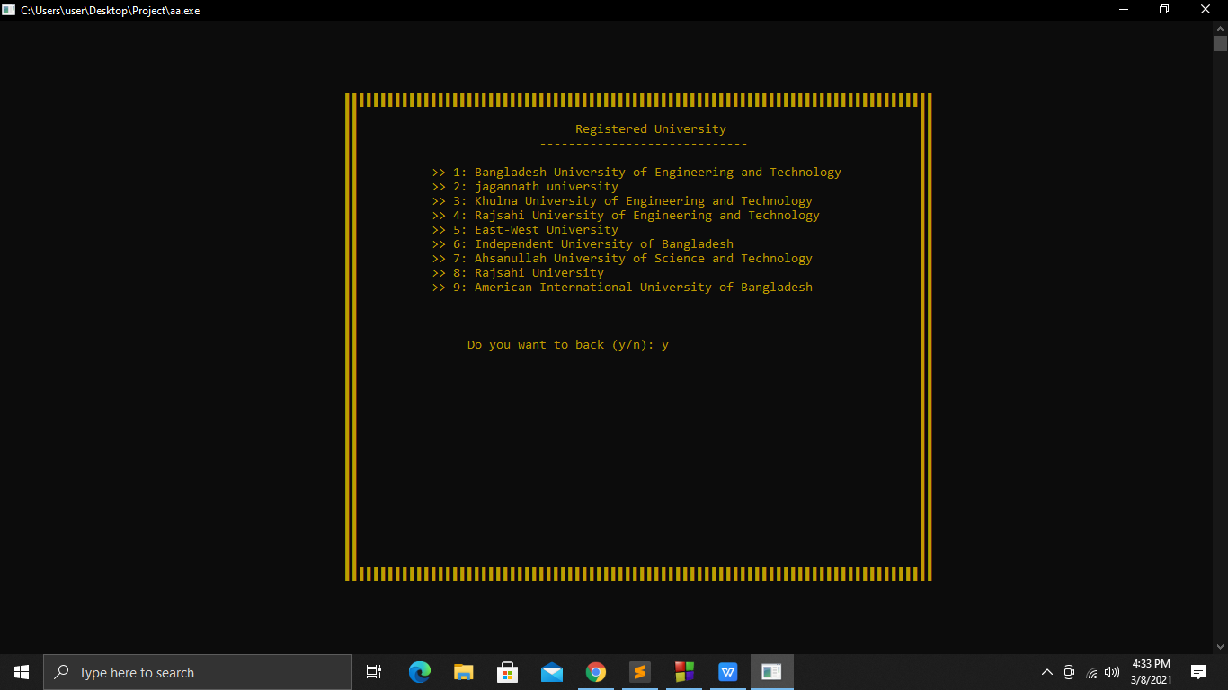

Figure:4.26

23. If any student press 2, the registered university will show again. If anyone want to see admit card he/she have to press the serial number and the admit card will be shown. like figure:(4.27), figure:(4.28) and figure:(4.29).

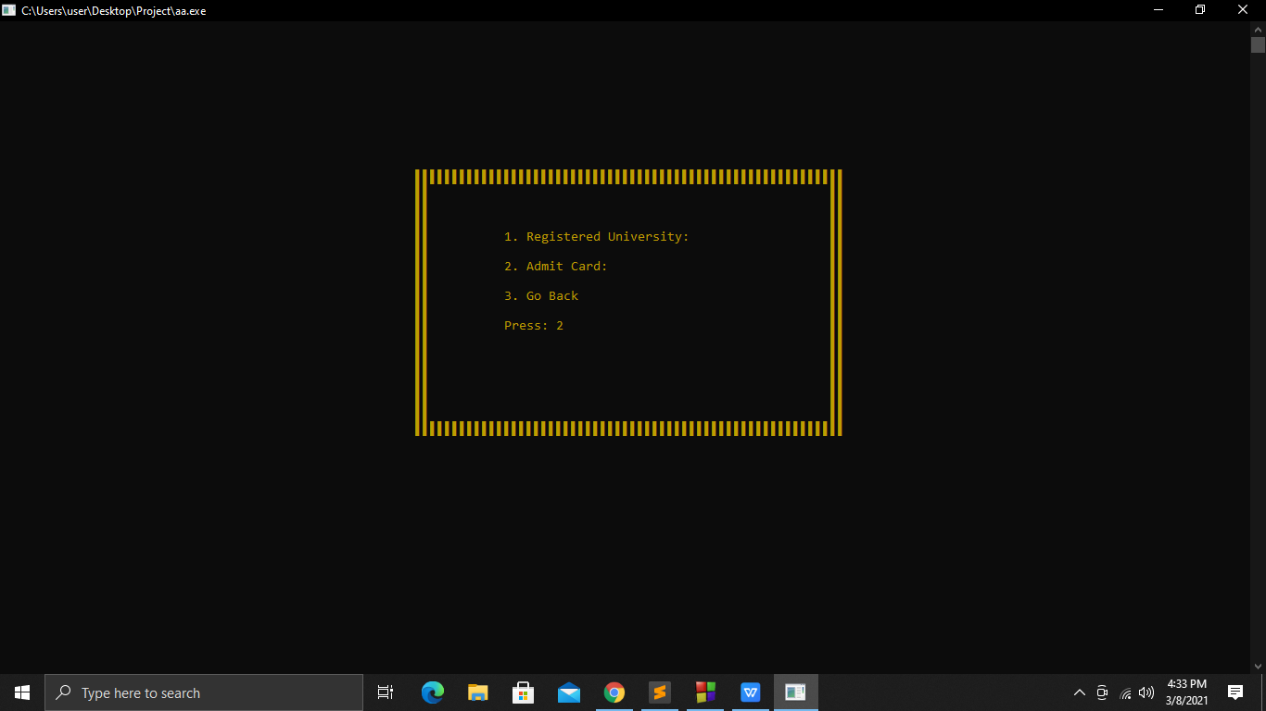

Figure: 4.27

Chapter 4. Access System 22

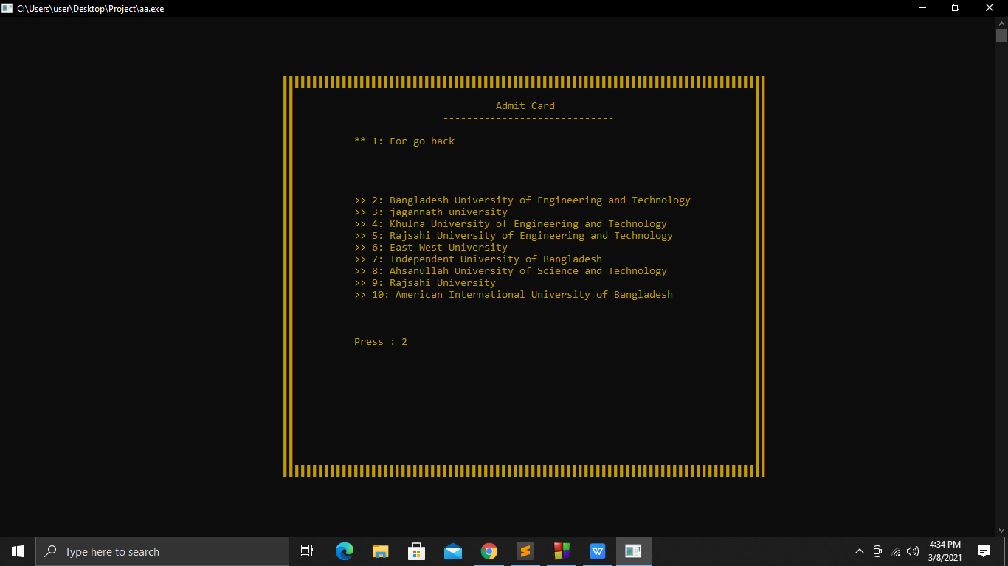

Figure: 4.28

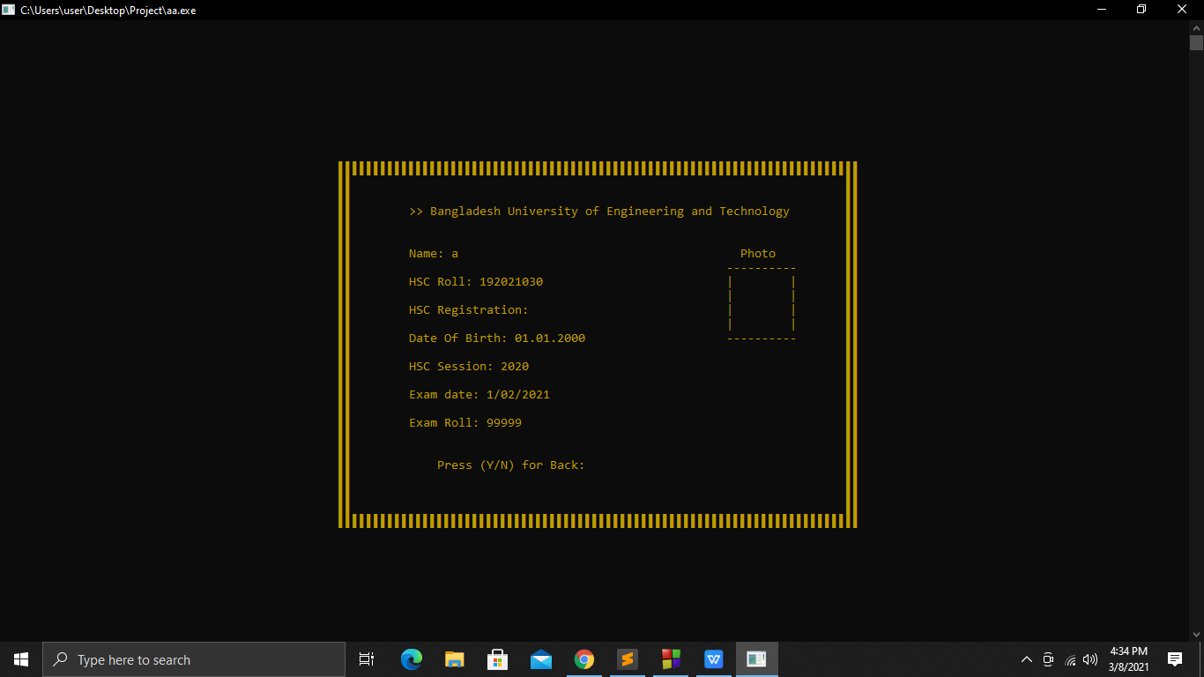

Figure: 4.29

24. After viewing the admit card, students have to press “y” to go to the previous page. Like figure :(4.30)

Chapter 4. Access System 23

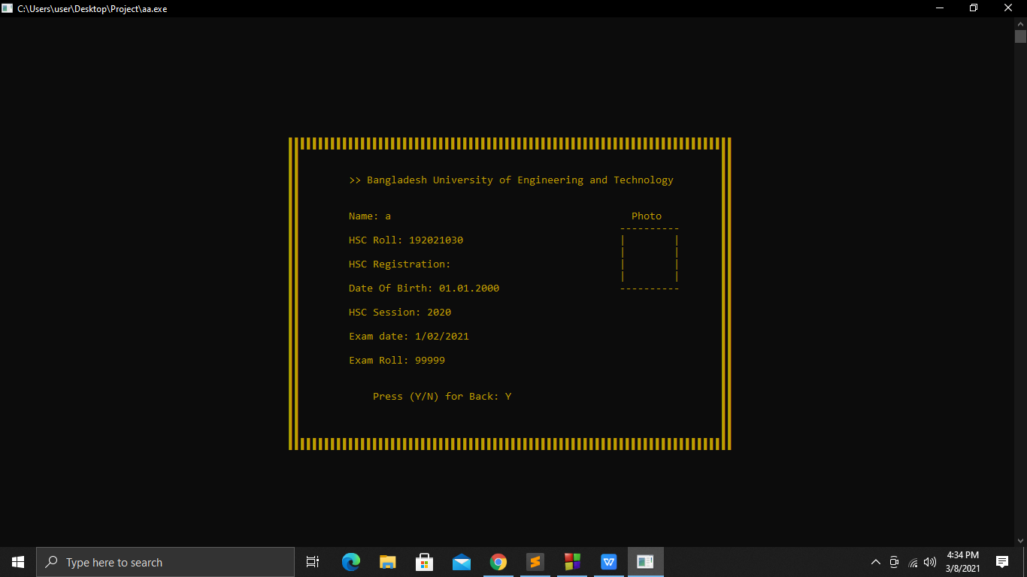

Figure: 4.30

25. If any student press 1 again, it will go back to figure:4.24 like figure:(4.31).

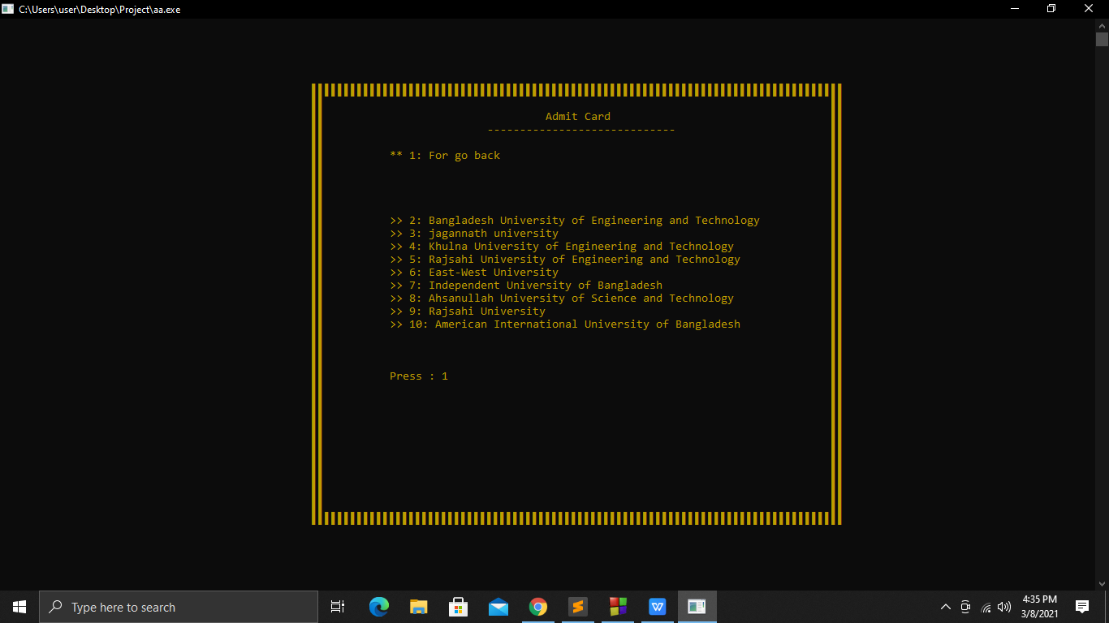

Figure: 4.31

Chapter 4. Access System 24

26. After pressing 3 it will go back to home page again like figure:(4.32).

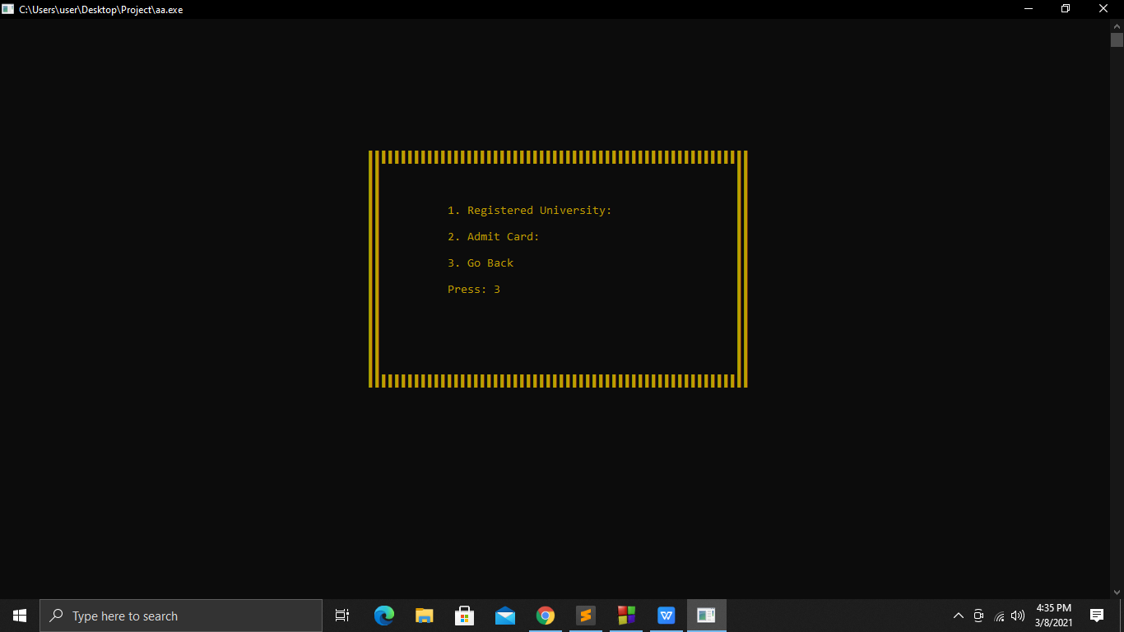

Figure:4.32

27. If any student come to the home page and press 4, they can see the circular and exam date like figure :(4.33).

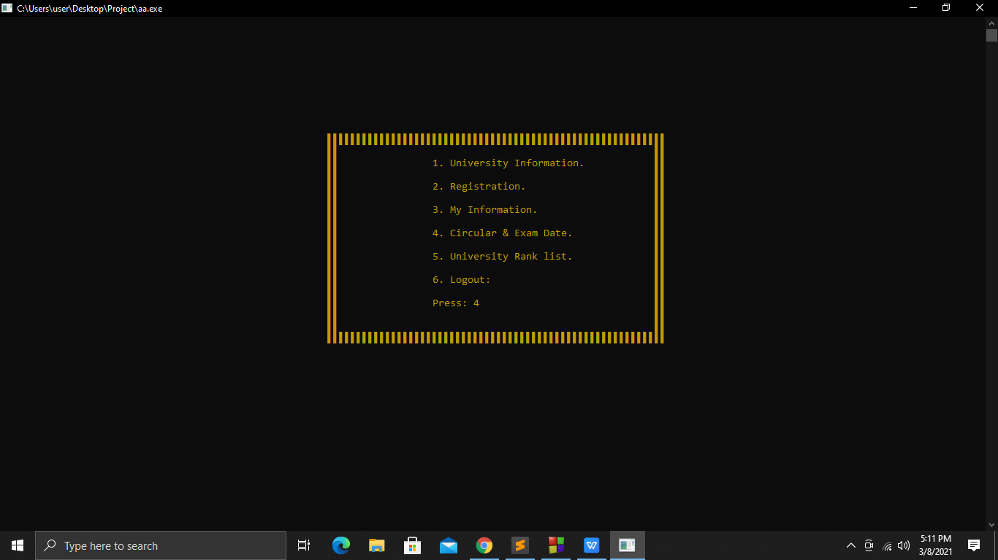

Figure:4.33

Chapter 4. Access System 25

28. Circular and exam date details can be seen by going to circular and exam date option and pressing the serial number of the University of Students choice. Like figure : (4.34) and figure:(4.35)

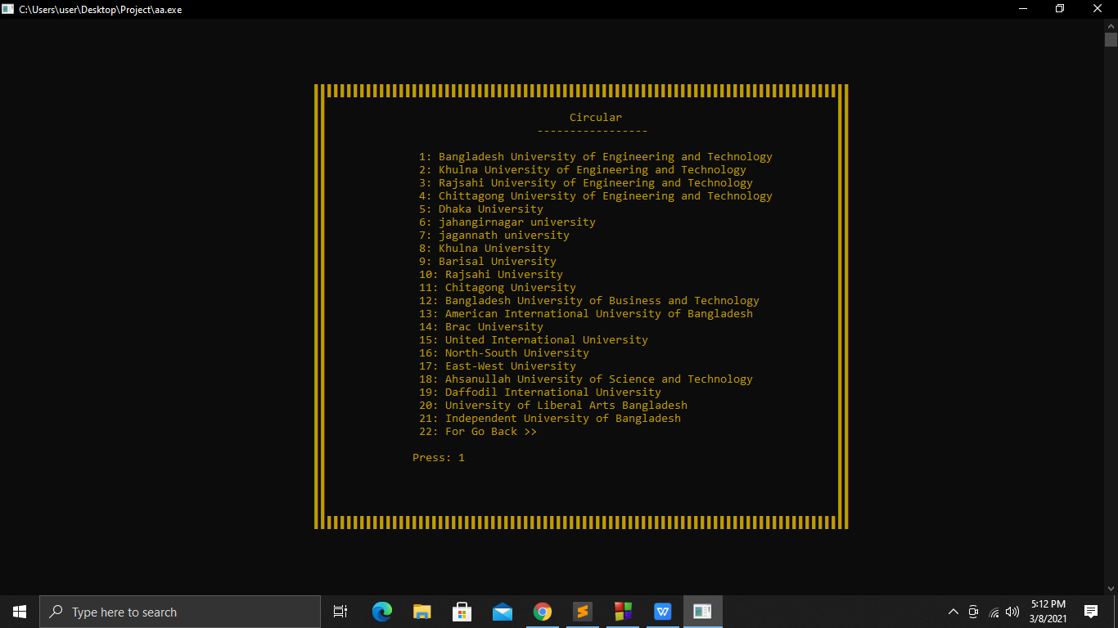

Figure: 4.34

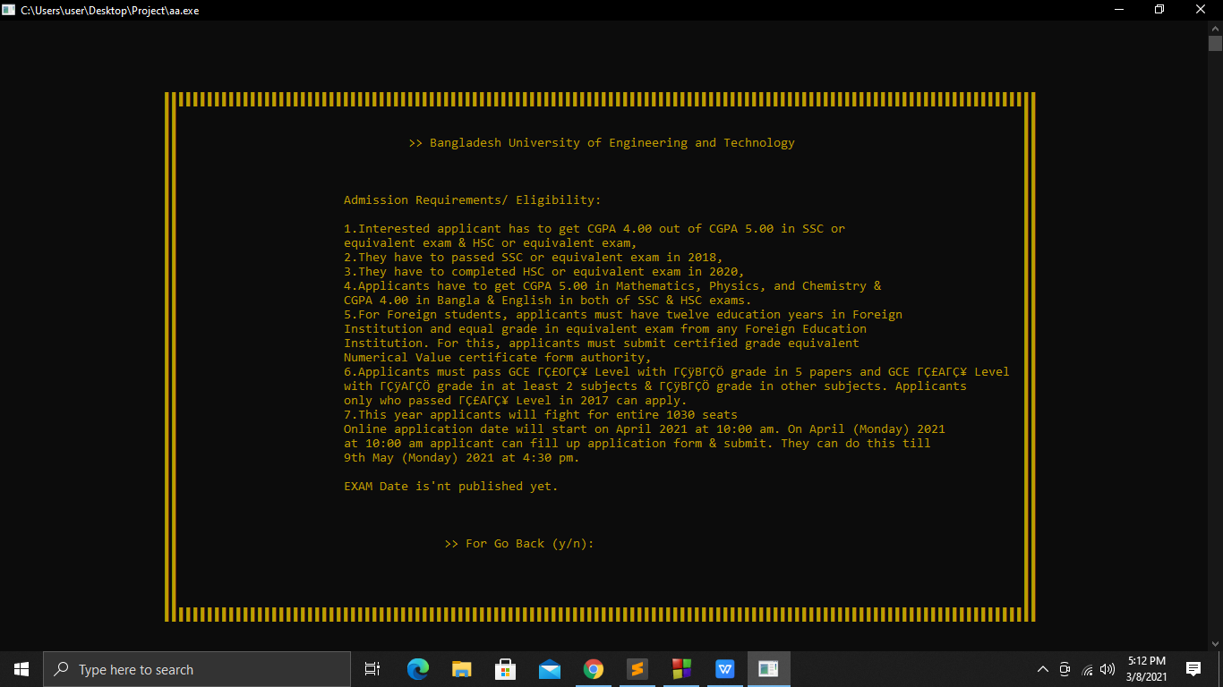

Figure: 4.35

Chapter 4. Access System 26

29. After viewing the circular and exam date, students have to press “y” to go to the previous page. Like figure :(4.36)

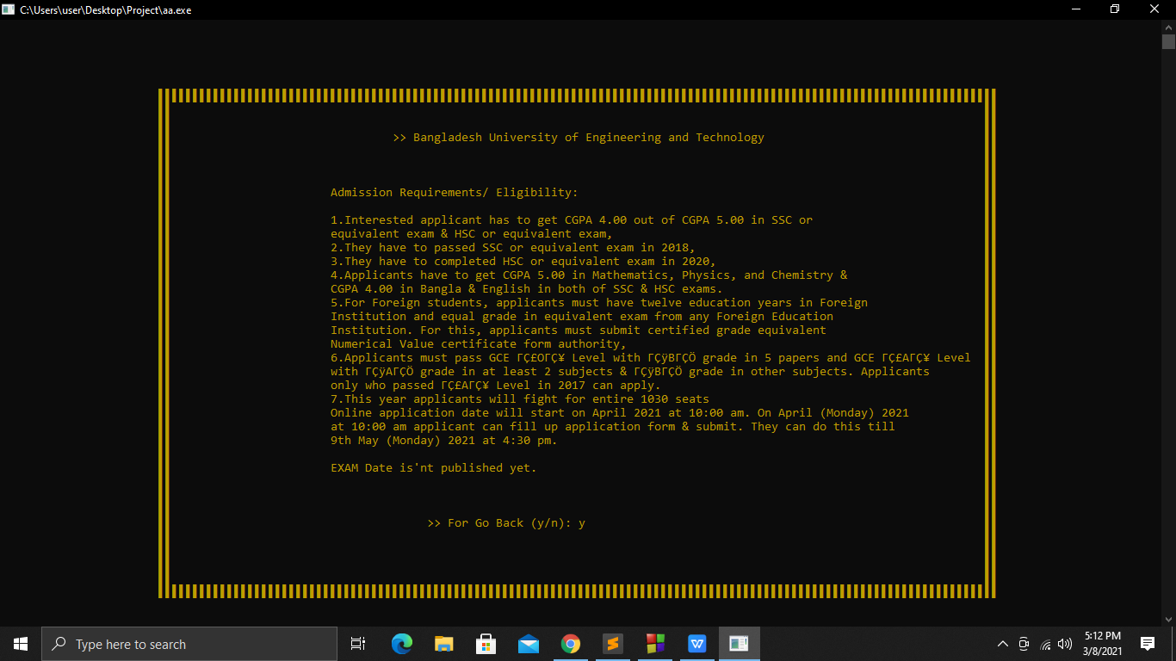

Figure: 4.36

30. If any student press 22 again like figure:(4.37).It will go back to the home page.

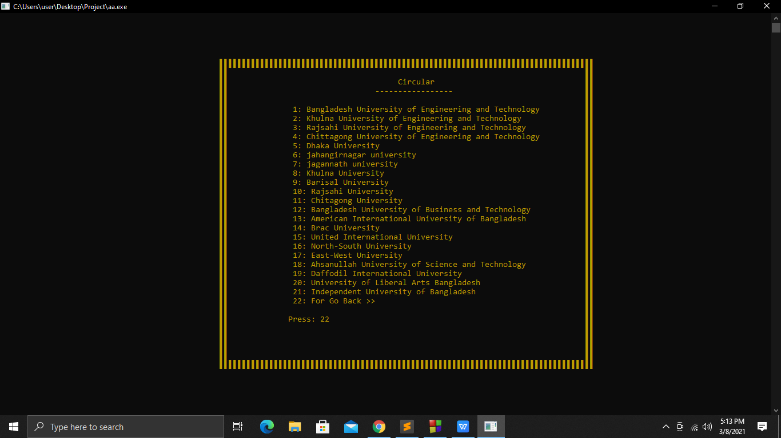

Figure: 4.37

Chapter 4. Access System 27

31.Students will be able to see the university rank list by pressing 5 on the home page like figure :(4.38)

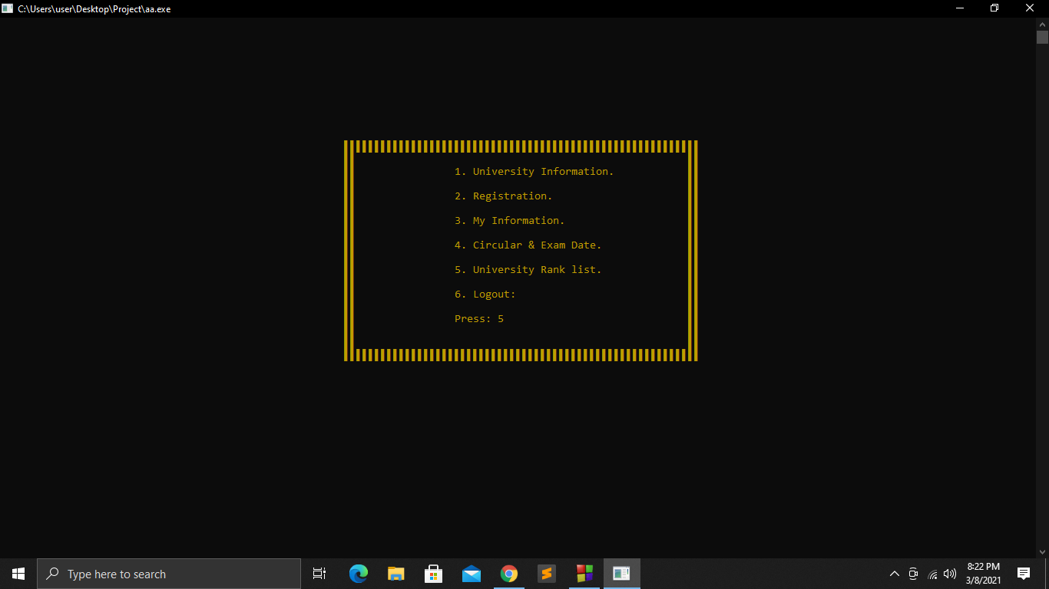

Figure: 4.38

32. There are two options on the rank list page. If any student press 1 then it will return to the previous page. And if any student press 2 then they will go to the next page like figure : (4.39).

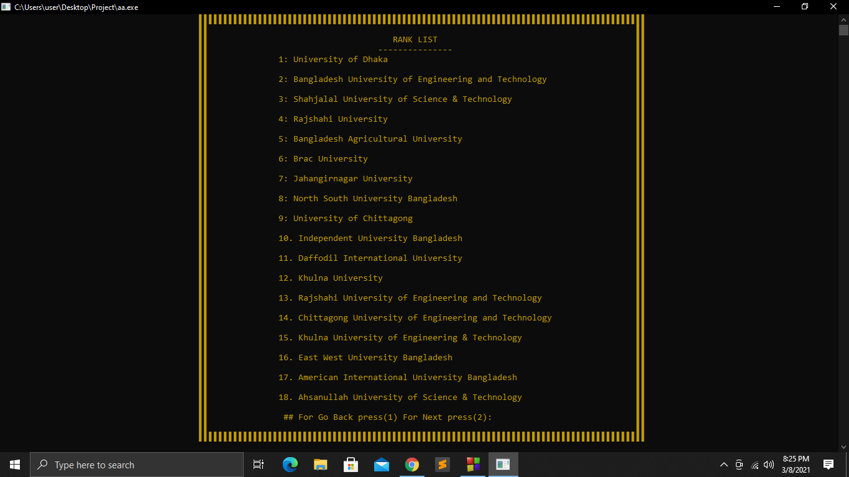

Figure:4.39

33. At the end of all, there is a logout option to exit the project. If any student press 6 then he/she will be out of the project like figure : (4.40).

Chapter 4. Access System 28

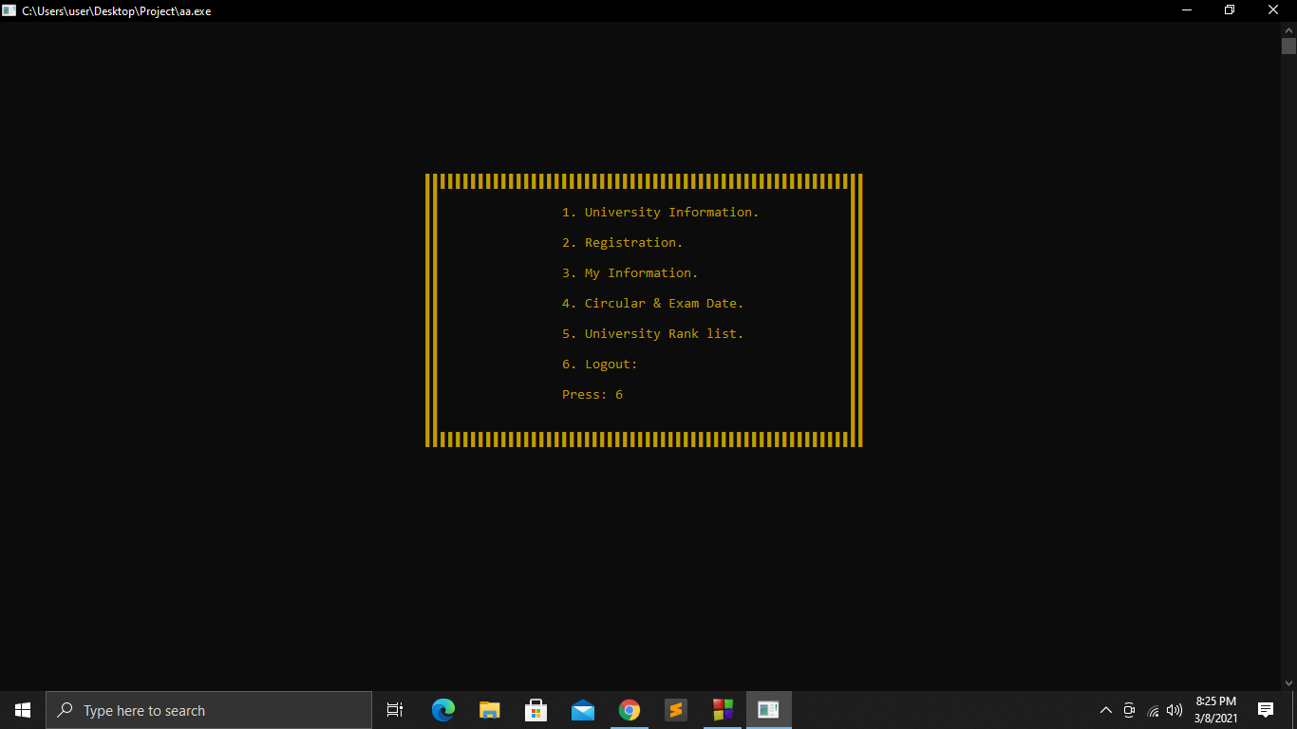

Figure: 4.40

Chapter 5. Code Analysis 29

Chapter 5

Code Analysis

5.1 Code:

#include<stdio.h>

#include<string.h>

#include<stdlib.h>

#include<time.h>

#include<windows.h>

void magic(int x, int y)

{

COORD coord;

coord.X = x;

coord.Y = y;

SetConsoleCursorPosition(GetStdHandle(STD_OUTPUT_HANDLE), coord);

}

void fy7()

{

system("color 06");

char ch=221;

magic(48,9);

for(int i=0; i<82; i++)

printf("%c",ch);

printf("\n");

for(int i=0; i<30; i++)

printf("\t\t\t\t\t\t%c%c\t\t\t\t\t\t \t\t\t%c%c\n",ch,ch,ch,ch);

magic(48,39);

for(int i=0; i<82; i++)

printf("%c",ch);

printf("\n");

}

void fy()

{

system("color 06");

char ch=221;

magic(56,10);

for(int i=0; i<58; i++)

Chapter 5. Code Analysis 30

printf("%c",ch);

printf("\n");

for(int i=0; i<17; i++)

printf("\t\t\t\t\t \t\t%c%c\t\t\t\t\t \t%c%c\n",ch,ch,ch,ch);

magic(56,27);

for(int i=0; i<58; i++)

printf("%c",ch);

printf("\n");

}

void fy1()

{

system("color 06");

char ch=221;

magic(56,12);

for(int i=0; i<66; i++)

printf("%c",ch);

printf("\n");

for(int i=0; i<19; i++)

printf("\t\t\t\t\t\t \t%c%c\t\t\t\t\t\t\t\t%c%c\n",ch,ch,ch,ch);

magic(56,32);

for(int i=0; i<66; i++)

printf("%c",ch);

printf("\n");

}

void fy4()

{

system("color 06");

char ch=221;

magic(48,10);

for(int i=0; i<74; i++)

printf("%c",ch);

printf("\n");

for(int i=0; i<25; i++)

printf("\t\t\t\t \t\t%c%c\t\t\t\t\t \t\t\t\t%c%c\n",ch,ch,ch,ch);

magic(48,35);

for(int i=0; i<74; i++)

printf("%c",ch);

printf("\n");

}

void loading()

{

char c;

float a;

for(int i=1; i<=24; i++)

{

Chapter 5. Code Analysis 31

c=221;

magic(75,13);

printf("Loading...\n\n");

a=(float)i/24*100;

magic(60,15);

printf("%.2f%% ",a);

for(int x=1; x<i; x++)

printf("%c",c);

if(i%1==0)

{

clock_t st = clock();

while (clock() < st+300);

}

//if(i<24)

//system("cls");

}

magic(60,17);

printf("\t Successfully Loaded");

clock_t st = clock();

while (clock() < st+1500);

system("cls");

}

char s[25][1000]= {"Bangladesh University of Engineering and Technology","Khulna University of Engineering and Technology","Rajsahi University of Engineering and Technology","Chittagong University of Engineering and Technology","Dhaka University",

"jahangirnagar university","jagannath university","Khulna University","Barisal University","Rajsahi University","Chitagong University","Bangladesh University of Business and Technology","American International University of Bangladesh","Brac University",

"United International University","North-South University","East-West University","Ahsanullah University of Science and Technology","Daffodil International University","University of Liberal Arts Bangladesh","Independent University of Bangladesh"

};

struct login

{

char person[30];

char password[30];

char number[20];

char date_birth[10];

char registration[100][100];

};

void fy6()

Chapter 5. Code Analysis 32

{

system("color 06");

char ch=221;

magic(24,2);

for(int i=0; i<122; i++)

printf("%c",ch);

printf("\n");

for(int i=0; i<40; i++)

printf("\t\t\t%c%c\t\t\t\t\t\t\t\t\t\t\t\t\t\t\t%c%c\n",ch,ch,ch,ch);

magic(24,42);

for(int i=0; i<120; i++)

printf("%c",ch);

printf("\n");

}

void display()

{

fy();

magic(74,12);

printf("1. University Information. \n");

magic(74,14);

printf("2. Registration. \n");

magic(74,16);

printf("3. My Information.\n");

magic(74,18);

printf("4. Circular & Exam Date. \n");

magic(74,20);

printf("5. University Rank list. \n");

magic(74,22);

printf("6. Logout:\n");

magic(74,24);

printf("Press: ");

}

void fy2()

{

system("color 06");

char ch=221;

magic(48,5);

for(int i=0; i<82; i++)

printf("%c",ch);

printf("\n");

for(int i=0; i<33; i++)

printf("\t\t\t\t\t\t%c%c\t\t\t\t\t\t \t\t\t%c%c\n",ch,ch,ch,ch);

magic(48,38);

for(int i=0; i<82; i++)

printf("%c",ch);

printf("\n");

}

Chapter 5. Code Analysis 33

void pub_pri()

{

fy2();

magic(50,7);

printf("\n\n\n\t\t\t\t\t\t\t\t1: Bangladesh University of Engineering and Technology\n");

printf("\t\t\t\t\t\t\t\t2: Khulna University of Engineering and Technology\n");

printf("\t\t\t\t\t\t\t\t3: Rajsahi University of Engineering and Technology\n");

printf("\t\t\t\t\t\t\t\t4: Chittagong University of Engineering and Technology\n");

printf("\t\t\t\t\t\t\t\t5: Dhaka University\n");

printf("\t\t\t\t\t\t\t\t6: Jahangirnagar university\n");

printf("\t\t\t\t\t\t\t\t7: Jagannath university\n");

printf("\t\t\t\t\t\t\t\t8: Khulna University\n");

printf("\t\t\t\t\t\t\t\t9: Barisal University\n");

printf("\t\t\t\t\t\t\t\t10: Rajsahi University\n");

printf("\t\t\t\t\t\t\t\t11: Chitagong University\n");

printf("\t\t\t\t\t\t\t\t12: Bangladesh University of Business and Technology\n");

printf("\t\t\t\t\t\t\t\t13: American International University of Bangladesh\n");

printf("\t\t\t\t\t\t\t\t14: Brac University\n");

printf("\t\t\t\t\t\t\t\t15: United International University\n");

printf("\t\t\t\t\t\t\t\t16: North-South University\n");

printf("\t\t\t\t\t\t\t\t17: East-West University\n");

printf("\t\t\t\t\t\t\t\t18: Ahsanullah University of Science and Technology\n");

printf("\t\t\t\t\t\t\t\t19: Daffodil International University\n");

printf("\t\t\t\t\t\t\t\t20: University of Liberal Arts Bangladesh\n");

printf("\t\t\t\t\t\t\t\t21: Independent University of Bangladesh\n");

printf("\t\t\t\t\t\t\t\t22: For Go Back >>");

}

void fy8()

{

system("color 06");

char ch=221;

magic(40,1);

for(int i=0; i<90; i++)

printf("%c",ch);

printf("\n");

for(int i=0; i<42; i++)

printf("\t\t\t\t\t%c%c\t\t\t\t\t\t\t\t\t\t\t%c%c\n",ch,ch,ch,ch);

magic(40,43);

for(int i=0; i<90; i++)

printf("%c",ch);

printf("\n");

}

void fy5()

{

system("color 06");

char ch=221;

Chapter 5. Code Analysis 34

magic(48,9);

for(int i=0; i<82; i++)

printf("%c",ch);

printf("\n");

for(int i=0; i<25; i++)

printf("\t\t\t\t \t\t%c%c\t\t\t\t\t \t \t\t\t\t%c%c\n",ch,ch,ch,ch);

magic(48,34);

for(int i=0; i<82; i++)

printf("%c",ch);

printf("\n");

}

void publicuniversity()

{

fy7();

magic(54,10);

printf("\n\t\t\t\t\t\t\t\t\t \tPublic University\n");

printf("\t\t\t\t\t\t\t\t\t ---------------------\n");

printf("\t\t\t\t\t\t\t1: Bangladesh University of Engineering and Technology\n\n");

printf("\t\t\t\t\t\t\t2: Khulna University of Engineering and Technology\n\n");

printf("\t\t\t\t\t\t\t3: Rajsahi University of Engineering and Technology\n\n");

printf("\t\t\t\t\t\t\t4: Chittagong University of Engineering and Technology\n\n");

printf("\t\t\t\t\t\t\t5: Dhaka University\n\n");

printf("\t\t\t\t\t\t\t6: Jahangirnagar university\n\n");

printf("\t\t\t\t\t\t\t7: Jagannath university\n\n");

printf("\t\t\t\t\t\t\t8: Khulna University\n\n");

printf("\t\t\t\t\t\t\t9: Barisal University\n\n");

printf("\t\t\t\t\t\t\t10: Rajsahi University\n\n");

printf("\t\t\t\t\t\t\t11: Chitagong University\n\n");

}

void pvtuniversity()

{

fy7();

magic(54,10);

printf("\n\t\t\t\t\t\t\t\t\t \tprivate University\n");

printf("\t\t\t\t\t\t\t\t\t ---------------------\n");

printf("\n\t\t\t\t\t\t\t1: Bangladesh University of Business and Technology\n\n");

printf("\t\t\t\t\t\t\t2: American International University of Bangladesh\n\n");

printf("\t\t\t\t\t\t\t3: Brac University\n\n");

printf("\t\t\t\t\t\t\t4: United International University\n\n");

printf("\t\t\t\t\t\t\t5: North-South University\n\n");

printf("\t\t\t\t\t\t\t6: East-West University\n\n");

printf("\t\t\t\t\t\t\t7: Ahsanullah University of Science and Technology\n\n");

printf("\t\t\t\t\t\t\t8: Daffodil International University\n\n");

printf("\t\t\t\t\t\t\t9: University of Liberal Arts Bangladesh\n\n");

printf("\t\t\t\t\t\t\t10: Independent University of Bangladesh\n\n");

Chapter 5. Code Analysis 35

}

void fy3()

{

system("cls");

char ch=221;

magic(23,5);

for(int i=0; i<122; i++)

printf("%c",ch);

printf("\n");

for(int i=0; i<35; i++)

printf("\t\t %c%c\t\t\t\t\t\t\t\t\t\t\t\t\t %c%c\n",ch,ch,ch,ch);

magic(23,41);

for (int i=0; i<122; i++)

printf("%c",ch);

printf("\n");

}

void regff(int a,char s[],char name[],char hsc_roll[],char hsc_reg[],char date_birth[],char hsc_pass[])

{

strcat(s,".txt");

FILE *pt;

pt=fopen(s,"w");

fprintf(pt,"Name: %s\n",name);

fprintf(pt,"HSC Roll: %s\n",hsc_roll);

fprintf(pt,"HSC Registration: %s\n",hsc_reg);

fprintf(pt,"Date Of Birth: %s\n",date_birth);

fprintf(pt,"HSC Session: %s\n",hsc_pass);

fprintf(pt,"Exam date: %d%s\n",a,"/02/2021");

fprintf(pt,"Exam Roll: %d",99999*a);

fclose(pt);

}

void username(char name[],char pars[])

{

strcat(name,".txt");

FILE *pt;

pt=fopen(name,"w");

fprintf(pt,"%s",pars);

fclose(pt);

}

int loginn(char name[],char password[])

{

strcat(name,".txt");

FILE *pt;

char ch[100];

pt=fopen(name,"r");

if(pt=='NULL')

return 0;

else

Chapter 5. Code Analysis 36

{

fscanf(pt,"%s",ch);

if(strcmp(password,ch)==0)

return 1;

else

return 0;

}

fclose(pt);

}

int main()

{

system("color 06");

loading();

yyy:

system("cls");

fy();

magic(68,16);

printf("Do you have any accound(y/n): ");

struct login per;

int count=0,wrong=0,flot=0;

int a;

char tt;

scanf("%c",&tt);

getchar();

if(tt=='y'||tt=='Y')

{

backs:

if(count!=0)

{

count=0;

getchar();

}

system("cls");

fy();

magic(84,12);

printf("Login");

magic(81,13);

printf("------------");

magic(64,15);

printf("Enter Your name: ");

gets(per.person);

magic(64,17);

printf("Enter Your password: ");

scanf("%s",&per.password);

Chapter 5. Code Analysis 37

getchar();

int log=loginn(per.person,per.password);

if(log==1)

{

magic(73,21);

printf("Successfully login....");

clock_t st = clock();

while (clock() < st+2500);

system("cls");

}

else

{

wrong++;

magic(70,20);

printf("**Wrong username or password ");

clock_t st = clock();

while (clock() < st+2500);

system("cls");

if(wrong>=3)

{

wrong=0;

system("cls");

fy();

magic(67,16);

printf("You gave 3 times wrong password");

magic(67,17);

printf("You should do Registration... ");

clock_t st = clock();

while (clock() < st+4500);

system("cls");

goto yyy;

}

goto backs;

}

}

else if(tt=='n'||tt=='N')

{

system("cls");

fy();

magic(81,12);

printf("Registration");

magic(79,13);

printf("----------------");

magic(64,15);

printf("Enter Your name: ");

gets(per.person);

magic(64,17);

printf("Enter Your password: ");

Chapter 5. Code Analysis 38

scanf("%s",&per.password);

magic(64,19);

printf("Enter your phone number: ");

scanf("%s",&per.number);

username(per.person,per.password);

magic(64,21);

printf("Date of birth: ");

scanf("%s",&per.date_birth);

magic(70,23);

printf("Successfully Registration....");

clock_t st = clock();

while (clock() < st+2500);

system("cls");

count++;

goto backs;

}

else

goto yyy;

while(1)

{

dak:

system("cls");

fy();

magic(2,5);

display();

int x;

scanf("%d",&x);

switch (x)

{

case 1:

{

bns:

system("cls");

fy();

magic(5,11);

printf("\n\n\t\t\t\t\t\t\t\t\t1: Public University\n");

printf("\n\n\t\t\t\t\t\t\t\t\t2: Private University\n");

printf("\n\n\t\t\t\t\t\t\t\t\t3: For Go to Back ");

printf("\n\n\n\t\t\t\t\t\t\t\t\tPress: ");

int n;

scanf("%d",&n);

switch (n)

{

case 1:

{

cns:

system("cls");

printf("\n\n\n\n\n");

Chapter 5. Code Analysis 39

publicuniversity();

printf("\t\t\t\t\t\t\t12. Do you want to go back : ");

printf("\n\n\t\t\t\t\t\t\tPress: ");

int a;

scanf("%d",&a);

printf("\n\n\n");

if(a==1)

{

system("cls");

FILE *p;

char c;

p=fopen("BUET.txt","r");

magic(60,2);

while(1)

{

c=fgetc(p);

if(c==EOF)

break;

printf("%c",c);

}

getchar();

fy6();

char cc;

magic(4,35);

printf("\t\t\t\t\t\t\tDo you want to back (y/n): ");

scanf("%c",&cc);

if(cc=='y')

goto cns;

fclose(p);

}

else if(a==2)

{

system("cls");

FILE *p;

char c;

p=fopen("KUET.txt","r");

while(1)

{

c=fgetc(p);

if(c==EOF)

break;

printf("%c",c);

}

getchar();

fy6();

char cc;

magic(4,39);

printf("\t\t\t\t\t\t\tDo you want to back (y/n): ");

Chapter 5. Code Analysis 40

scanf("%c",&cc);

if(cc=='y')

goto cns;

fclose(p);

}

else if(a==3)

{

system("cls");

FILE *p;

char c;

p=fopen("RUET.txt","r");

while(1)

{

c=fgetc(p);

if(c==EOF)

break;

printf("%c",c);

}

getchar();

fy6();

char cc;

magic(4,39);

printf("\t\t\t\t\t\t\tDo you want to back (y/n): ");

scanf("%c",&cc);

if(cc=='y')

goto cns;

fclose(p);

}

else if(a==4)

{

system("cls");

FILE *p;

char c;

p=fopen("CUET.txt","r");

while(1)

{

c=fgetc(p);

if(c==EOF)

break;

printf("%c",c);

}

getchar();

fy6();

char cc;

magic(4,39);

printf("\t\t\t\t\t\t\tDo you want to back (y/n): ");

scanf("%c",&cc);

if(cc=='y')

Chapter 5. Code Analysis 41

goto cns;

fclose(p);

}

else if(a==5)

{

system("cls");

FILE *p;

char c;

p=fopen("DU.txt","r");

while(1)

{

c=fgetc(p);

if(c==EOF)

break;

printf("%c",c);

}

getchar();

fy6();

char cc;

magic(4,39);

printf("\t\t\t\t\t\t\tDo you want to back (y/n): ");

scanf("%c",&cc);

if(cc=='y')

goto cns;

fclose(p);

}

else if(a==6)

{

system("cls");

FILE *p;

char c;

p=fopen("JU.txt","r");

while(1)

{

c=fgetc(p);

if(c==EOF)

break;

printf("%c",c);

}

getchar();

fy6();

char cc;

magic(4,39);

printf("\t\t\t\t\t\t\tDo you want to back (y/n): ");

scanf("%c",&cc);

if(cc=='y')

goto cns;

fclose(p);

Chapter 5. Code Analysis 42

}

else if(a==7)

{

system("cls");

FILE *p;

char c;

p=fopen("JNU.txt","r");

while(1)

{

c=fgetc(p);

if(c==EOF)

break;

printf("%c",c);

}

getchar();

fy6();

char cc;

magic(4,39);

printf("\t\t\t\t\t\t\tDo you want to back (y/n): ");

scanf("%c",&cc);

if(cc=='y')

goto cns;

fclose(p);

}

else if(a==8)

{

system("cls");

FILE *p;

char c;

p=fopen("KU.txt","r");

while(1)

{

c=fgetc(p);

if(c==EOF)

break;

printf("%c",c);

}

getchar();

fy6();

char cc;

magic(4,39);

printf("\t\t\t\t\t\t\tDo you want to back (y/n): ");

scanf("%c",&cc);

if(cc=='y')

goto cns;

fclose(p);

}

else if(a==9)

Chapter 5. Code Analysis 43

{

system("cls");

FILE *p;

char c;

p=fopen("BU.txt","r");

while(1)

{

c=fgetc(p);

if(c==EOF)

break;

printf("%c",c);

}

getchar();

fy6();

char cc;

magic(4,39);

printf("\t\t\t\t\t\t\tDo you want to back (y/n): ");

scanf("%c",&cc);

if(cc=='y')

goto cns;

fclose(p);

}

else if(a==10)

{

system("cls");

FILE *p;

char c;

p=fopen("RU.txt","r");

while(1)

{

c=fgetc(p);

if(c==EOF)

break;

printf("%c",c);

}

getchar();

fy6();

char cc;

magic(4,39);

printf("\t\t\t\t\t\t\tDo you want to back (y/n): ");

scanf("%c",&cc);

if(cc=='y')

goto cns;

fclose(p);

}

else if(a==11)

{

system("cls");

Chapter 5. Code Analysis 44

FILE *p;

char c;

p=fopen("CU.txt","r");

while(1)

{

c=fgetc(p);

if(c==EOF)

break;

printf("%c",c);

}

getchar();

fy6();

char cc;

magic(4,39);

printf("\t\t\t\t\t\t\tDo you want to back (y/n): ");

scanf("%c",&cc);

if(cc=='y')

goto cns;

fclose(p);

}

else if(a==12)

{

goto bns;

}

// goto

break;

}

case 2:

{

tt:

system("cls");

printf("\n\n\n\n\n");

pvtuniversity();

printf("\t\t\t\t\t\t\t11. Do you want to go back : ");

printf("\n\n\t\t\t\t\t\t\tPress: ");

int a;

scanf("%d",&a);

printf("\n\n\n");

if(a==1)

{

system("cls");

FILE *p;

char c;

p=fopen("BUBT.txt","r");

while(1)

{

c=fgetc(p);

Chapter 5. Code Analysis 45

if(c==EOF)

break;

printf("%c",c);

}

getchar();

fy6();

char cc;

magic(4,37);

printf("\t\t\t\t\t\t\tDo you want to back (y/n): ");

scanf("%c",&cc);

if(cc=='y')

goto tt;

fclose(p);

}

else if(a==2)

{

system("cls");

FILE *p;

char c;

p=fopen("AIUB.txt","r");

while(1)

{

c=fgetc(p);

if(c==EOF)

break;

printf("%c",c);

}

getchar();

fy6();

char cc;

magic(4,38);

printf("\t\t\t\t\t\t\tDo you want to back (y/n): ");

scanf("%c",&cc);

if(cc=='y')

goto tt;

fclose(p);

}

else if(a==3)

{

system("cls");

FILE *p;

char c;

p=fopen("BRAC.txt","r");

while(1)

{

c=fgetc(p);

if(c==EOF)

Chapter 5. Code Analysis 46

break;

printf("%c",c);

}

getchar();

fy6();

char cc;

magic(4,37);

printf("\t\t\t\t\t\t\tDo you want to back (y/n): ");

scanf("%c",&cc);

if(cc=='y')

goto tt;

fclose(p);

}

else if(a==4)

{

system("cls");

FILE *p;

char c;

p=fopen("UIU.txt","r");

while(1)

{

c=fgetc(p);

if(c==EOF)

break;

printf("%c",c);

}

getchar();

fy6();

char cc;

magic(4,35);

printf("\t\t\t\t\t\t\tDo you want to back (y/n): ");

scanf("%c",&cc);

if(cc=='y')

goto tt;

fclose(p);

}

else if(a==5)

{

system("cls");

FILE *p;

char c;

p=fopen("NSU.txt","r");

while(1)

{

c=fgetc(p);

if(c==EOF)

break;

printf("%c",c);

Chapter 5. Code Analysis 47

}

getchar();

fy6();

char cc;

magic(4,39);

printf("\t\t\t\t\t\t\tDo you want to back (y/n): ");

scanf("%c",&cc);

if(cc=='y')

goto tt;

fclose(p);

}

else if(a==6)

{

system("cls");

FILE *p;

char c;

p=fopen("EWU.txt","r");

while(1)

{

c=fgetc(p);

if(c==EOF)

break;

printf("%c",c);

}

getchar();

fy6();

char cc;

magic(4,39);

printf("\t\t\t\t\t\t\tDo you want to back (y/n): ");

scanf("%c",&cc);

if(cc=='y')

goto tt;

fclose(p);

}

else if(a==7)

{

system("cls");

FILE *p;

char c;

p=fopen("AUST.txt","r");

while(1)

{

c=fgetc(p);

if(c==EOF)

break;

printf("%c",c);

}

getchar();

Chapter 5. Code Analysis 48

fy6();

char cc;

magic(4,39);

printf("\t\t\t\t\t\t\tDo you want to back (y/n): ");

scanf("%c",&cc);

if(cc=='y')

goto tt;

fclose(p);

}

else if(a==8)

{

system("cls");

FILE *p;

char c;

p=fopen("DIU.txt","r");

while(1)

{

c=fgetc(p);

if(c==EOF)

break;

printf("%c",c);

}

getchar();

fy6();

char cc;

magic(4,39);

printf("\t\t\t\t\t\t\tDo you want to back (y/n): ");

scanf("%c",&cc);

if(cc=='y')

goto tt;

fclose(p);

}

else if(a==9)

{

system("cls");

FILE *p;

char c;

p=fopen("ULAB.txt","r");

while(1)

{

c=fgetc(p);

if(c==EOF)

break;

printf("%c",c);

}

getchar();

fy6();

char cc;

Chapter 5. Code Analysis 49

magic(4,39);

printf("\t\t\t\t\t\t\tDo you want to back (y/n): ");

scanf("%c",&cc);

if(cc=='y')

goto tt;

fclose(p);

}

else if(a==10)

{

system("cls");

FILE *p;

char c;

p=fopen("IUB.txt","r");

while(1)

{

c=fgetc(p);

if(c==EOF)

break;

printf("%c",c);

}

getchar();

fy6();

char cc;

magic(4,39);

printf("\t\t\t\t\t\t\tDo you want to back (y/n): ");

scanf("%c",&cc);

if(cc=='y')

goto tt;

fclose(p);

}

else if(a==11)

{

goto bns;

}

break;

}

case 3:

{

goto dak;

}

break;

}

break;

}

case 2:

{

Chapter 5. Code Analysis 50

system("cls");

Char

ll[10],name[20],hsc_roll[10],hsc_reg[10],date_birth[10],hsc_pass[10];

magic(83,7);

printf("Registration\n");

magic(81,8);

printf("-----------------------\n");

pub_pri();

printf("\n\n\t\t\t\t\t\t\t\tPress: ");

int a;

scanf("%d",&a);

printf("\n\t\t\t\t\t\t\t\t\t\tPlease wait for processing.....");

clock_t st = clock();

while (clock() < st+4000);

if(a!=22)

{

system("cls");

fy4();

magic(22,12);

char y;

printf("\n\t\t\t\t\t\t\t\t>> %s",s[a-1]);

printf("\n\n\n\n\t\t\t\t\t\t\tEnter your name: ");

getchar();

gets(name);

printf("\n\t\t\t\t\t\t\tEnter your hsc roll: ");

scanf("%s",&hsc_roll);

printf("\n\t\t\t\t\t\t\tEnter your hsc reg: ");

scanf("%s",&hsc_reg);

printf("\n\t\t\t\t\t\t\tEnter your birth date : ");

scanf("%s",&date_birth);

printf("\n\t\t\t\t\t\t\tEnter your hsc passed year: ");

scanf("%s",&hsc_pass);

getchar();

printf("\n\t\t\t\t\t\t\tFor Next press(y): ");

scanf("%c",&y);

printf("\n\n\t\t\t\t\t\t\t\t\tPlease wait for processing.....");

clock_t sl = clock();

while (clock() < sl+3500);

system("cls");

if(y=='y'||y=='Y')

{

system("cls");

fy();

int d;

magic(79,12);

printf("payment method\n");

magic(76,13);

printf("--------------------\n");

Chapter 5. Code Analysis 51

magic(70,15);

printf("1. Bkash\n");

magic(70,17);

printf("2. Rocket\n");

magic(70,19);

printf("3. Nogod\n");

magic(70,21);

printf("press: ");

scanf("%d",&d);

magic(71,23);

printf("Please wait for processing.....");

clock_t sl = clock();

while (clock() < sl+3500);

system("cls");

if(d==1)

{

system("cls");

fy5();

char sn[20][20],rc[20][20],in[20][20];

magic(88,12);

printf("Bkash \n");

magic(83,13);

printf("---------------\n");

magic(53,14);

printf("Go to bKash Menu by dialing 247# Choose 'Payment' option by pressing '3'\n");

magic(53,15);

printf("Enter our Merchant wallet number :01****.Enter amount.After completing\n");

magic(53,16);

printf("this process you will get a confirmation message. Then fill up the form.\n");

magic(65,20);

printf("Sender Number: ");

scanf("%s",&sn);

magic(65,22);

printf("Recieved Code: ");

scanf("%s",&rc);

magic(65,24);

printf("Id Number: ");

scanf("%s",&in);

magic(72,28);

printf("Successfully Registered......");

clock_t st = clock();

while (clock() < st+3500);

system("cls");

{

Chapter 5. Code Analysis 52

int i=0;

FILE *p;

char c;

int len=strlen(s[a-1]);

p=fopen("registration.txt","a");

while(len--)

{

c=s[a-1][i++];

fprintf(p,"%c",c);

}

fprintf(p, "\n");

fclose(p);

}

regff(a,s[a-1],name,hsc_roll,hsc_reg,date_birth,hsc_pass);

}

else if(d==2)

{

system("cls");

fy5();

char sn[20][20],rc[20][20],in[20][20];

magic(88,12);

printf("Rocket \n");

magic(83,13);

printf("---------------\n");

magic(53,14);

printf("Go to your Rocket Mobile Menu by dialing *322#.Choose Bill Pay.\n");

magic(53,15);

printf("Choose Self or Others.Enter Your Bill Number:**Enter the bill amount:**.\n");

magic(53,16);

printf("Now enter your Rocket Mobile.Menu PIN to confirm.Done!You will receive a \n");

magic(53,17);

printf("confirmation message from 16216.Then fill up the from.");

magic(65,21);

printf("Sender Number: ");

scanf("%s",&sn);

magic(65,23);

printf("Recieved Code: ");

scanf("%s",&rc);

magic(65,25);

printf("Id Number: ");

scanf("%s",&in);

magic(72,28);

printf("Successfully Registered.......");

clock_t st = clock();

Chapter 5. Code Analysis 53

while (clock() < st+3500);

system("cls");

system("cls");

{

int i=0;

FILE *p;

char c;

int len=strlen(s[a-1]);

p=fopen("registration.txt","a");

while(len--)

{

c=s[a-1][i++];

fprintf(p,"%c",c);

}

fprintf(p, "\n");

fclose(p);

}

regff(a,s[a-1],name,hsc_roll,hsc_reg,date_birth,hsc_pass);

}

else if(d==3)

{

system("cls");

fy5();

char sn[20][20],rc[20][20],in[20][20];

magic(88,12);

printf("Nogod \n");

magic(83,13);

printf("---------------\n");

magic(53,14);

printf("Go to your Rocket Mobile Menu by dialing *322#.Choose Bill Pay.\n");

magic(53,15);

printf("Choose Self or Others.Enter Your Bill Number:**Enter the bill amount:**.\n");

magic(53,16);

printf("Now enter your Rocket Mobile.Menu PIN to confirm.Done!You will receive a \n");

magic(53,17);

printf("confirmation message from 16216.Then fill up the from.");

magic(65,21);

printf("Sender Number: ");

scanf("%s",&sn);

magic(65,23);

printf("Recieved Code: ");

scanf("%s",&rc);

magic(65,25);

printf("Id Number: ");

Chapter 5. Code Analysis 54

scanf("%s",&in);

magic(72,28);

printf("Successfully Registered.......");

clock_t st = clock();

while (clock() < st+3500);

system("cls");

system("cls");

{

int i=0;

FILE *p;

char c;

int len=strlen(s[a-1]);

p=fopen("registration.txt","a");

while(len--)

{

c=s[a-1][i++];

fprintf(p,"%c",c);

}

fprintf(p, "\n");

fclose(p);

}

regff(a,s[a-1],name,hsc_roll,hsc_reg,date_birth,hsc_pass);

}

}

}

else

goto dak;

break;

}

case 3:

{

int quee=0;

ie:

system("cls");

fy();

magic(68,14);

printf("1. Registered University: ");

magic(68,16);

printf("2. Admit Card: ");

magic(68,18);

printf("3. Go Back");

magic(68,20);

printf("Press: ");

int pr;

scanf("%d",&pr);

if(pr==1)

{

Chapter 5. Code Analysis 55

system("cls");

fy2();

FILE *p;

char c[10000];

int i=10,ll=1;

p=fopen("registration.txt","r");

magic(80,7);

printf("Registered University");

magic(75,8);

printf("-----------------------------");

while(fgets(c,100,p)!=NULL)

{

magic(60,i++);

printf(">> %d: ",ll++);

puts(c);

}

fclose(p);

magic(65,i+3);

printf("Do you want to back (y/n): ");

getchar();

char cc;

scanf("%c",&cc);

if(cc=='y')

goto ie;

else

goto dak;

}

else if(pr==2)

{

while(1)

{

system("cls");

fy2();

FILE *p;

char chh[100][100];

int e=1;

int i=10,ll=1;

p=fopen("registration.txt","r");

magic(84,7);

printf("Admit Card");

magic(75,8);

printf("-----------------------------");

magic(60,i++);

i=i+4;

printf("** %d: For go back ",ll++);

while(fgets(chh[e++],100,p)!=NULL)

{

magic(60,i++);

Chapter 5. Code Analysis 56

printf(">> %d: ",ll++);

puts(chh[e-1]);

}

fclose(p);

magic(60,i+3);

getchar();

printf("Press : ");

int cc;

scanf("%d",&cc);

if(cc==1)

goto ie;

else

{

system("cls");

{

int i=16;

FILE *q;

char ccc[100];

char buf[100];

char cuf[100];

for(int w=0; w<=100; w++)

{

ccc[w]=NULL;

buf[w]=NULL;

cuf[w]=NULL;

}

strcat(buf,chh[cc-1]);

for(int jj=0; jj<strlen(buf)-1; jj++)

cuf[jj]=buf[jj];

strcat(cuf,".txt");

//getchar();

q=fopen(cuf,"r");

fy4();

magic(58,13);

printf(">> %s",chh[cc-1]);

magic(105,16);

printf("Photo");

magic(103,17);

printf("----------");

magic(103,18);

printf("| |");

magic(103,19);

printf("| |");

magic(103,20);

printf("| |");

magic(103,21);

printf("| |");

magic(103,22);

Chapter 5. Code Analysis 57

printf("----------");

while(fgets(ccc,1000,q)!=NULL)

{

magic(58,i++);

puts(ccc);

i++;

}

i++;

fclose(q);

magic(62,i++);

getchar();

printf("Press (Y/N) for Back: ");

char kk;

scanf("%c",&kk);

printf("\n\t\t\t\t\t\t\t\t\tPlease wait for processing.....");

quee++;

clock_t sl = clock();

while (clock() < sl+3500);

system("cls");

if(kk=='Y'||kk=='y')

{

}

else

goto ie;

}

}

}

}

else if(pr==3)

{

goto dak;

}

}

case 4:

{

bak:

system("cls");

pub_pri();

magic(87,7);

printf("Circular \n");

magic(82,8);

printf("-----------------\n");

magic(63,33);

printf("Press: ");

int dd;

scanf("%d",&dd);

Chapter 5. Code Analysis 58

magic(74,35);

printf("Please wait for processing.....");

clock_t sl = clock();

while (clock() < sl+2500);

system("cls");

getchar();

if(dd==22)

break;

else if(dd>=1 &&dd<=21)

{

system("cls");

fy3();

char n;

magic(57,8);

printf(">> %s",s[dd-1]);

FILE *p;

char c;

p=fopen("circular.txt","r");

while(1)

{

c=fgetc(p);

if(c==EOF)

break;

printf("%c",c);

}

fclose(p);

magic(62,36);

printf(">> For Go Back (y/n): ");

scanf("%c",&n);

if(n=='y'||n=='Y')

{

goto bak;

}

else

goto dak;

}

}

case 5:

{

int i=1;

while(i>=1&&i<=6)

{

system("cls");

printf("\n");

FILE *p;

char c;

if(i==1)

{

Chapter 5. Code Analysis 59

p=fopen("RANK1.txt","r");

}

else if(i==2)

{

p=fopen("RANK2.txt","r");

}

else if(i==3)

{

p=fopen("RANK3.txt","r");

}

else if(i==4)

{

p=fopen("RANK4.txt","r");

}

else if(i==5)

{

p=fopen("RANK5.txt","r");

}

else if(i==6)

{

p=fopen("RANK6.txt","r");

}

while(1)

{

c=fgetc(p);

if(c==EOF)

break;

printf("%c",c);

}

fy8();

magic(57,41);

if(i==6)

printf("## for Go Back press(1): ");

else

printf("## For Go Back press(1) For Next press(2): ");

int dd;

scanf("%d",&dd);

if(i==1&&dd==1)

goto dak;

if(dd==1)

i--;

else if(dd==2)

i++;

else

goto dak;

}

break;

Chapter 5. Code Analysis 60

}

case 6:

{

system("cls");

flot=1;

}

}

if(flot==1)

break;

}

}

Chapter 6. Conclusion 61

Chapter 6

6.1 Future Plan

The first plan in our future is to deliver this project to the students who will take admission in universities and also delivered to all universities. We will try to make our offline project into web based. We will even try to create this project as an app. At present we only know about the information of certain universities in Bangladesh. But in the future, we will improve the information, registration information and every single details of all the universities in Bangladesh as well as the foreign universities so that the students can have it at home.

Chapter 7. Conclusion 62

Chapter 7

7.1 Conclusion

Students who have just passed HSC can get help by using our admission assistant project. University location, where and when to register, how to register, how many places there are in a university, all students have to wear a little problem. But it is possible to solve this problem through our report Time wastage can be prevented by using our project. Our project is designed to alleviate the suffering of students. Any student can get an idea about the University of their Choice. Can register in an accurate way. They do not have to worry about payment system. This project is a helping side to the students.